

Course notes for small boat sailing scheme

Table of Contents
1. Taste of Sailing 5
Clothing & Equipment: 5
Sailing Techniques & Manoeuvres: 5
Capsize Recovery: 8
What Next? 8
2. Start Sailing 9
Clothing & Equipment: 9
What to Wear & Why 9
Types of materials 10
Buoyancy aid vs lifejacket 10
What the Numbers and Pictures Mean 10
Rigging: 11
Ropework: 12
figure of eight knot.: 12
round turn and two half hitches: 12
Secure a rope using a Cam Cleat: 12
Can secure a rope using a Horned cleat: 12
Can secure a rope using a Jam cleat: 12
Can coil a line by flaking it into one hand and secure it to stop it uncoiling. 12
Can throw one end of a coiled line. 12
Launch & Recovery: Getting In & Out of the Water! 12
Sailing Techniques & Manoeuvres: 13
Capsize Recovery: 17
Sailing Knowledge: 18
Points of Sailing 18
Collision Avoidance (Rules of the Road) 19
Environmental Awareness 20
Safety Equipment 20
Sailing Terminology 20
Coastal Knowledge: Understanding Your Environment 21
Tidal Cycles 21
Implications of Tides on Sailing Activities 21
Weather & Safety: 22
Understanding Wind Direction and Its Impact 22
Understanding Wind Strength and Its Impact 23
General Safety Practices 23
What Next? Keep on Sailing! Error! Bookmark not defined.
3. Basic Skills 24
Clothing and Equipment: Essential Preparation for Sailing 24
Personal Preparation: Clothing Choices 24
Boat Preparation: Essential Equipment and Checks 25
Rigging: 26
Rigging the Boat for Use 26
Sail Selection and Reefing Decisions 26
Sail Controls: The Outhaul 27
Reefing Techniques 27
Ropework: Essential Knots for Sailing 28
The Bowline: 28
The Clove Hitch: 28
Sailing Techniques & Manoeuvres: 29
Boat Control 29
The 5 Essentials: 29
Core Sailing Manoeuvres 30
Docking and Mooring 30
Man Overboard Recovery: 31
Capsize Recovery: 32
Sailing Knowledge: Principles of Sail Trim and Collision Avoidance 32
How Your Boat Moves 32
Collision Avoidance: Rules of the Road 33
Coastal Knowledge: Understanding Tides and Tidal Streams 34
Understanding Tides 34
Understanding Tidal Streams 34
Weather: Understanding Conditions for Safe Sailing 35
Understanding Weather Elements and Their Impact 35
Safety: Essential Practices and Emergency Response 37
Pre-Sailing Safety Planning 37
Emergency Equipment and Care 37
Main Types of Distress Flares (Commonly Carried on Boats): 38
Emergency Care 39
What Next? 39
4. Improving Skills 40
Rigging and Boat Care: 40
Rigging Your Own Boat 40
De-Rigging and Post-Sailing Care 41
Tuning: 42
Key Tuning Controls and Their Use 42
Optimising Performance Across Conditions 44
Boat Handling: Advanced Manoeuvres and Independent Control 45
Advanced Turns: Tacking and Gybing 45
Precise Docking and Mooring 46
Specialized Manoeuvres and Control 46
Emergency Response 49
Continuous Application of Principles 49
Capsize Recovery: 50
Recovering from an Inverted Capsize 50
Boat Speed: 51
Foundational Principles for Speed 51
Setting Up for Performance 51
Efficient Sailing on All Points 51
Weather: Advanced Forecasting and Meteorological Interpretation 53
Impact of Weather Elements on Planned Activities 53
Sources of Weather Forecasts and Their Characteristics 54
Interpreting Marine Forecast Terminology and Synoptic Charts 55
Applying Forecasts to Sailing Plans 56
Coastal Knowledge: Understanding Tides and Their Effects 56
What Causes Tides 56
Neap and Spring Tides and Their Impact 56
Sailing Knowledge: Hydrodynamics, Aerodynamics, and Force Dynamics 58
Understanding Forces: Lift Generation and Stalling 58
Force Interaction: Centre of Effort and Centre of Lateral Resistance 59
What Next? 59

Taste of Sailing
Objective: This course is your first introduction to sailing! It's all about having a blast and seeing how much fun sailing can be.

Clothing & Equipment:
To get ready for sailing, you'll learn that wearing a Personal Flotation Device (PFD) is super important. It helps you float like a cork if you accidentally fall in the water! Your instructor will show you how different PFDs work, like buoyancy aids (which are thinner and allow more movement, great for active sailing) and life jackets (which have more buoyancy and are designed to turn you face up, even if you're unconscious). You'll learn why we choose a buoyancy aid for dinghy sailing – it gives us freedom to move while keeping us safe. You'll also learn how to check it fits snugly and safely, so it doesn't ride up.
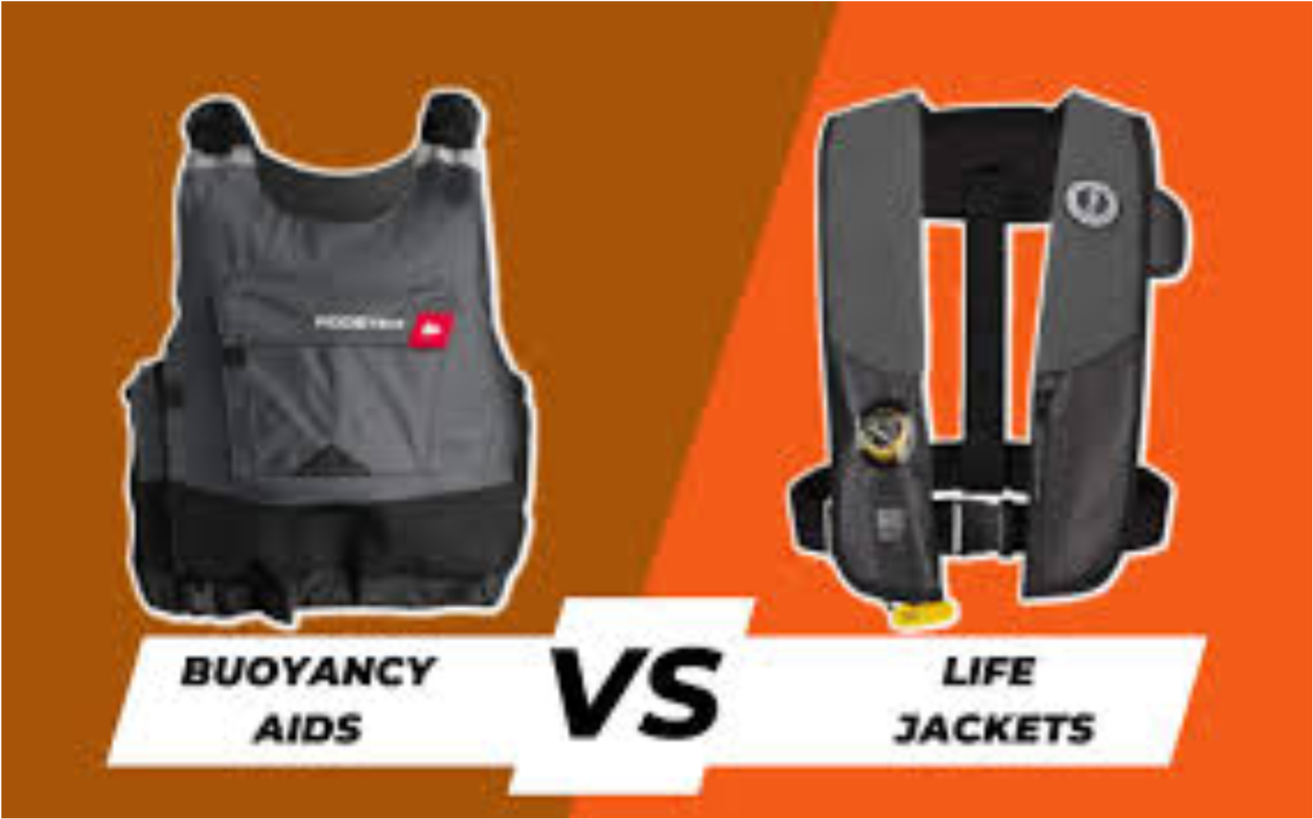

Sailing Techniques & Manoeuvres:
First, you'll learn to figure out where the wind is coming from. This is called identifying the "windward" side. Hold your hand up and feel it on your cheek, watch flags onshore, or look at the ripples on the water. On the boat, you can also look at a wind indicator at the top of the mast if your boat has one. You'll practice identifying the wind's direction from different spots on the boat to always know where the wind is coming from.
To sail straight across the wind (a "beam reach"), you'll gently hold the tiller (the steering stick). The tiller moves the rudder (the steering fin). To steer to the right, you push the tiller to the left, and vice versa. Use small, smooth movements – think of steering a bicycle, not a car! You'll also pull in your sail (the "sheet") just enough, so it's puffed up, making the boat go forward. The sail should be pulled in until it just stops flapping (flappy sail is not a happy sail). This balance between tiller and sail is key to going straight.
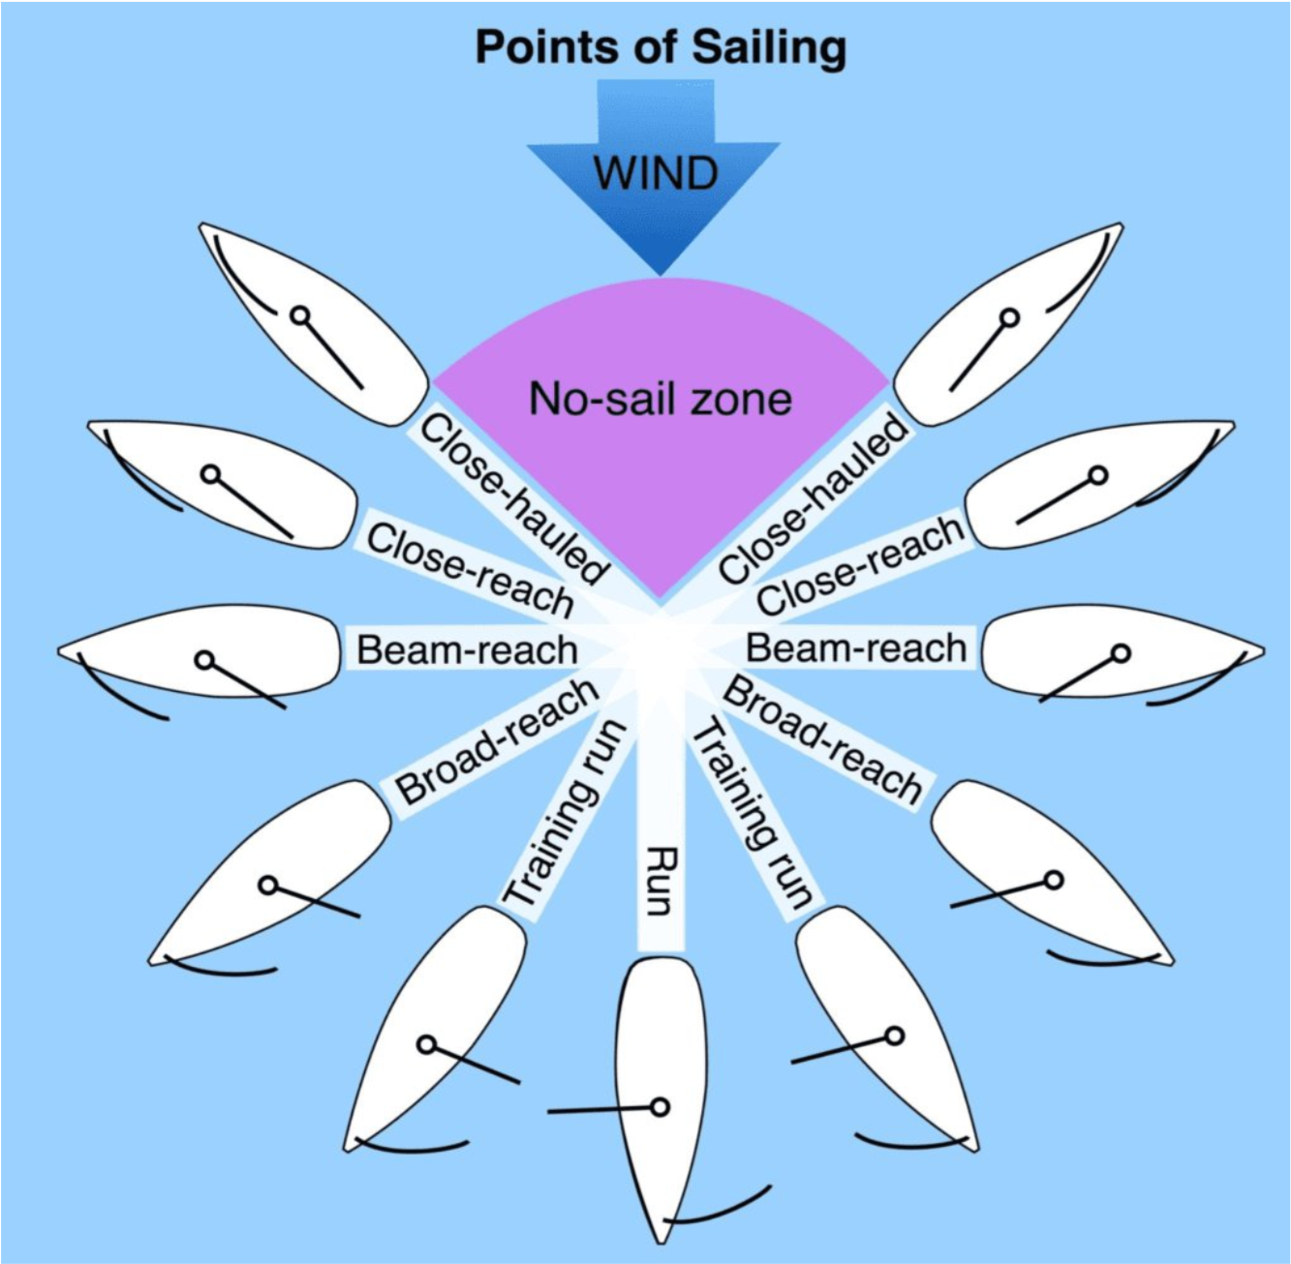
To stop the boat, you'll simply let your sail out all the way. This is called letting the sail "luff" (flap freely). The wind won't push it anymore, and the boat will slow down and stop, facing directly into the wind, a position called "in irons." When you're ready to go again, you'll pull your sail in until it fills and gently turn the tiller to catch the wind and start moving.
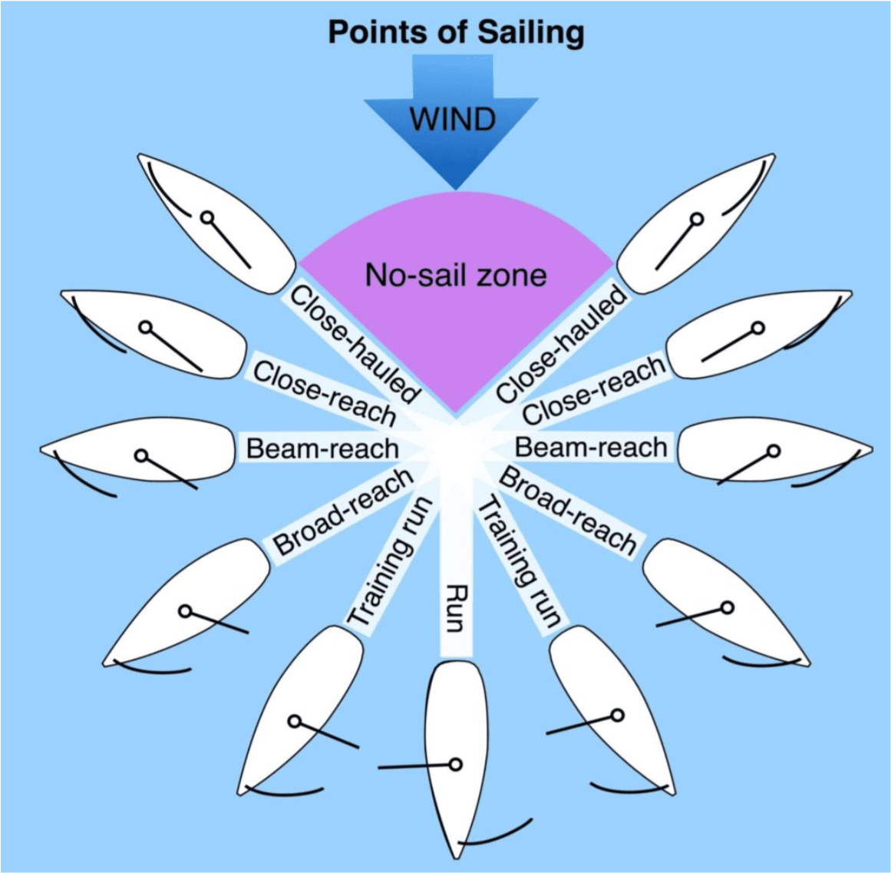
.

Turning the front of the boat through the wind is called tacking. This is a move where you change which side the wind is coming from (from one side to the other). You'll learn the sequence: turn the boat, then move smoothly from one side of the boat to the other (this is called "changing sides"), swapping hands on the tiller and main sheet. The key is smooth coordination between the helm (you, steering) and the crew (your sailing partner).
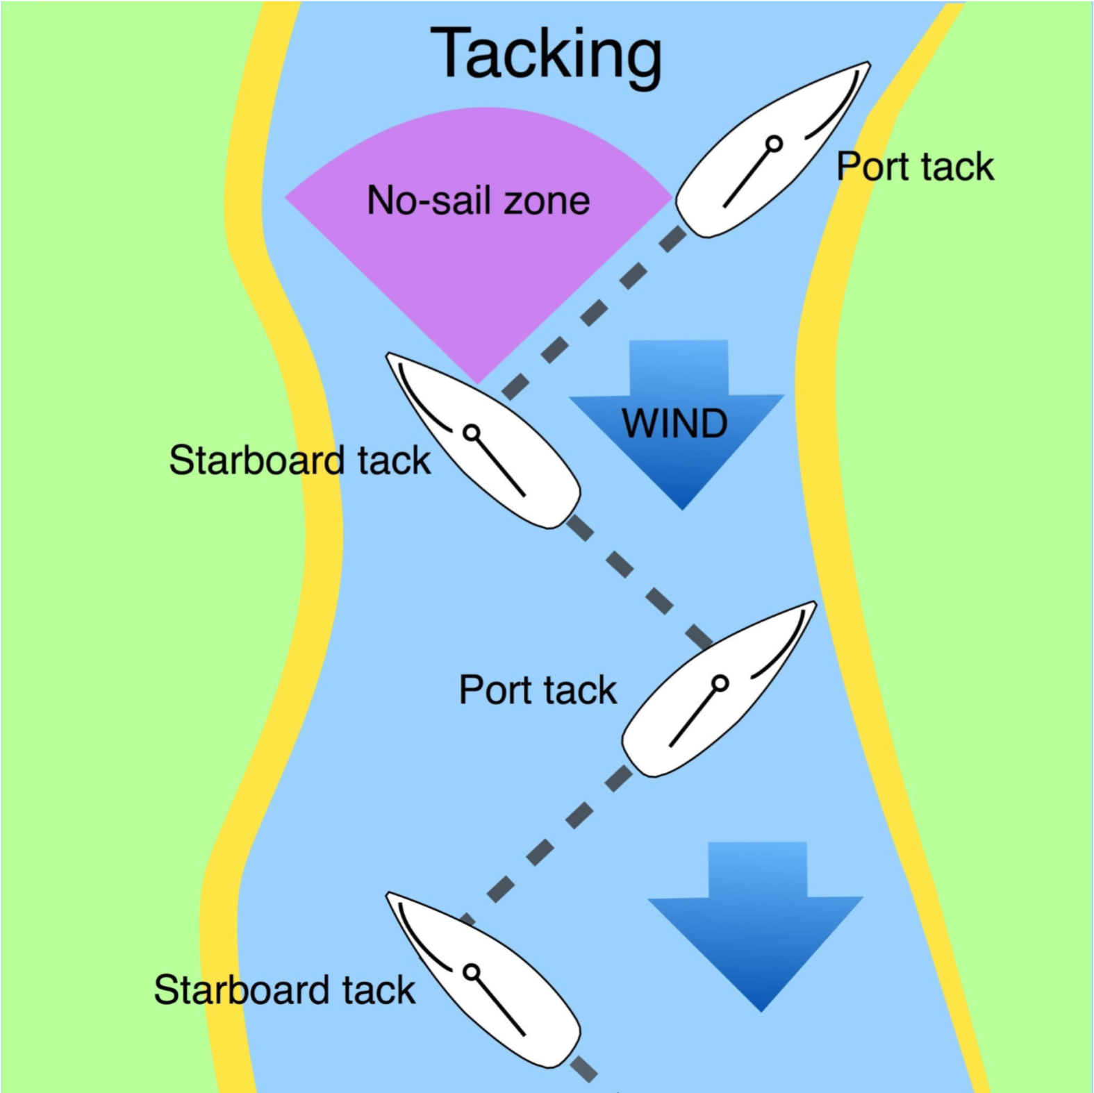
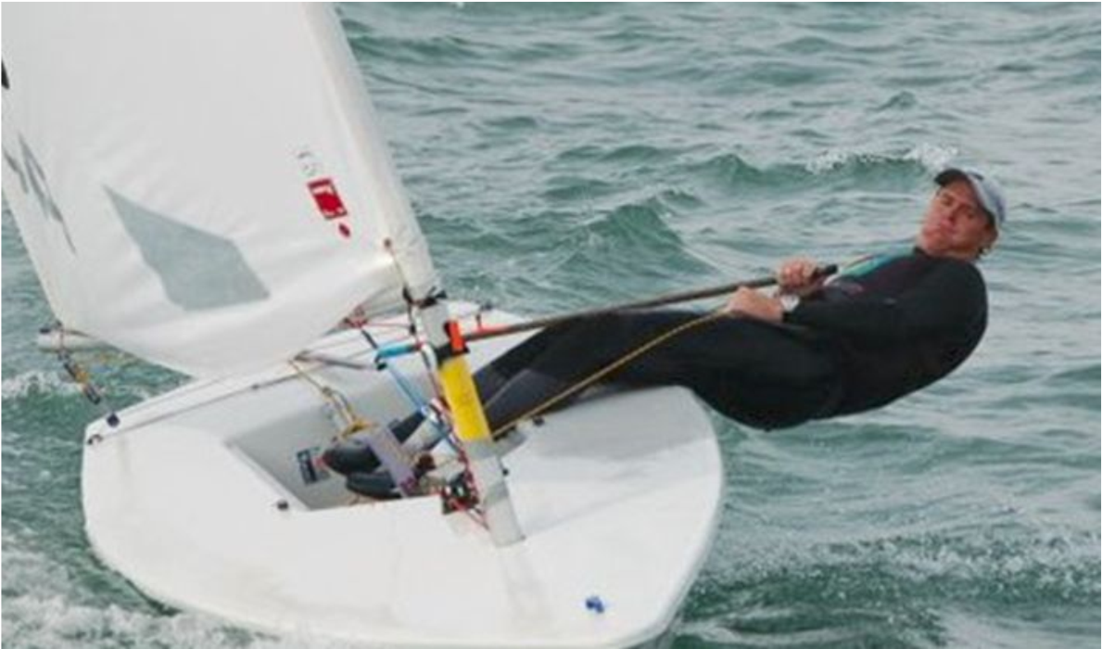
To keep the boat flat and happy, you'll learn to move your body weight. This is called "balancing" or "hiking." If the boat tips a little to one side (heels over), you lean your body weight to the other side to balance it, like a seesaw! This keeps the boat flatter.
You'll practice moving the daggerboard (or centreboard) up and down. This fin acts like a keel, stopping the boat from slipping sideways. When you're sailing, it goes down to help the boat go straight and point into the wind. When you're near shore or in shallow water, you pull it up, so it doesn't hit the bottom. The rudder goes down in the water to steer and up when you're finished or in shallow water.

Capsize Recovery:
If your boat ever tips over (capsizes), your instructor will teach you to always stay with your boat. It's your best friend in the water! You'll learn to hold onto it because it floats and is easy for others to spot. You'll understand that swimming to shore from a capsized boat is much harder and less safe than staying with the boat – your boat is your floating island! You'll also learn simple actions to prevent the boat from going completely upside down (called an "inversion"), such as quickly swimming around to the daggerboard and putting your weight on it.
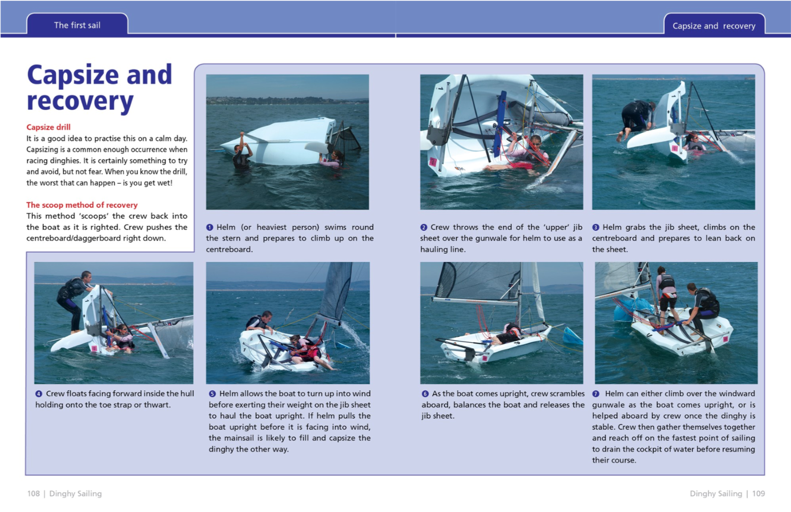

What Next?
Your instructor will tell you all about the next exciting course, "Start Sailing," and how it builds on what you've learned here.

Start Sailing
Objective: You're ready to sail mostly on your own in gentle winds, with a little help from your instructor! This is your first official sailing course!

Clothing & Equipment:
To prepare for your sail, you'll learn to look at the weather and decide what clothes are best. Think layers (so you can add or remove clothes as the temperature changes), waterproof jackets (to stay dry from spray and rain), and proper shoes that won't slip (like sailing boots). You'll practice putting on your own PFD correctly and making sure it fits snugly and safely, checking all the buckles and straps. Before you even get in the water, you'll learn to do a quick visual check of your boat to make sure everything looks good and safe – like checking ropes for knots, making sure the rudder and daggerboard are ready, and that the sails aren't tangled.

What to Wear & Why
Item | Why to Wear | Why not to wear
Hat – beanie  Sun hat -Try and get one with a clip so it doesn’t blow off | -to stop your head getting cold (lots of heat escapes from your head!)  -to keep the sun out of your eyes and off your face | NA
Sunglasses- again clip if possible | To protect your eyes from the bright sun reflecting off the water. It can be super glary! | If it's dark or cloudy
Footwear: | Closed-toe shoes with good grip! This keeps your feet safe from bumps and stops you from slipping on wet decks. | Flip-flops or sandals. They offer no protection, and you'll slip and slide!
Gloves | To protect your hands from ropes and to help you grip things better, especially when it's cold. | NA
Wetsuits | If the water is cold! They trap a thin layer of water that your body warms up, keeping you cosy even when you're wet. | If the water is warm, you'll get too hot! (no chance here!)
Drysuit | They completely block water and keep you fully dry even if you fall in- wear if you want to stay fully dry | If you plan to get wet
Waterproofs | If you know you will not enter the water e.g. on larger yachts | If you plan to get into the water

Types of materials
Material | Benefit | Drawback
Cotton | When you're completely dry and it's warm. | When cotton gets wet, it stays wet, gets heavy, and makes you cold.
Wool | Keeps you warm even when it's wet! It also breathes well | NA
Synthetic  fibre | Good for sailing: These materials are great because they dry fast and move sweat away from your skin, keeping you dry and warm. | NA

Buoyancy aid vs lifejacket
Feature | Buoyancy Aid (50N) | Lifejacket (100N, 150N, 275N)
What it does | Helps you float easily if you fall in, but you need to be able to swim a bit. It won't turn you onto your back if you're knocked out. | Designed to turn you onto your back so your face is out of the water, even if you're unconscious (knocked out).
When we use them | For most sailing activities where you're active and can swim. | For people who can't swim well, or if we're sailing far from shore or in rougher conditions where it's more dangerous.


What the Numbers and Pictures Mean
Imagine it like a secret code that helps you know your gear is safe!
· ISO/EN Number (like "ISO 12402"):
· ISO stands for International Organization for Standardization. Think of it as a worldwide club that sets rules for how good and safe products should be.
· EN stands for European Norm. This means it also meets special safety rules for Europe.
· When you see an ISO/EN number, it's like a "safety stamp". It tells you that your buoyancy aid or lifejacket has been tested and passed strict safety checks, so you know it's superior quality and will do its job to keep you safe! ·
Pictures (Pictograms):
· These are like small, quick drawings that give you essential information without needing words.
· "50N," "100N," etc.: The "N" stands for Newtons, which is a way of measuring how much your PFD helps you float. A higher number means it helps you float more!
· Weight Range (e.g., "25-40kg"): This picture tells you the weight of the person the PFD is designed for. It's super important to wear one that fits your weight to keep you safe!
· You might also see other pictures showing how to put it on correctly or how to look after it (like washing it).

Rigging:
Before you put up your sails, you'll learn to point the front of your boat directly into the wind, which is called head to wind. This is crucial because it stops the sails from flapping uncontrollably and makes it easier and safer to rig your boat. You'll learn the names of all the important parts of your boat, like the mast (the tall pole), the boom (the stick at the bottom of the sail), the rudder (for steering), and the sails themselves (the main sail and maybe a jib). You'll also learn about the "rigging" – all the ropes (like halyards for raising sails, and sheets for controlling sails) and wires (like shrouds and forestay that hold the mast up) that hold the mast up and control the sails. You'll actively help your instructor set up your boat for sailing, putting the mast up, attaching the boom, and getting the sails ready.
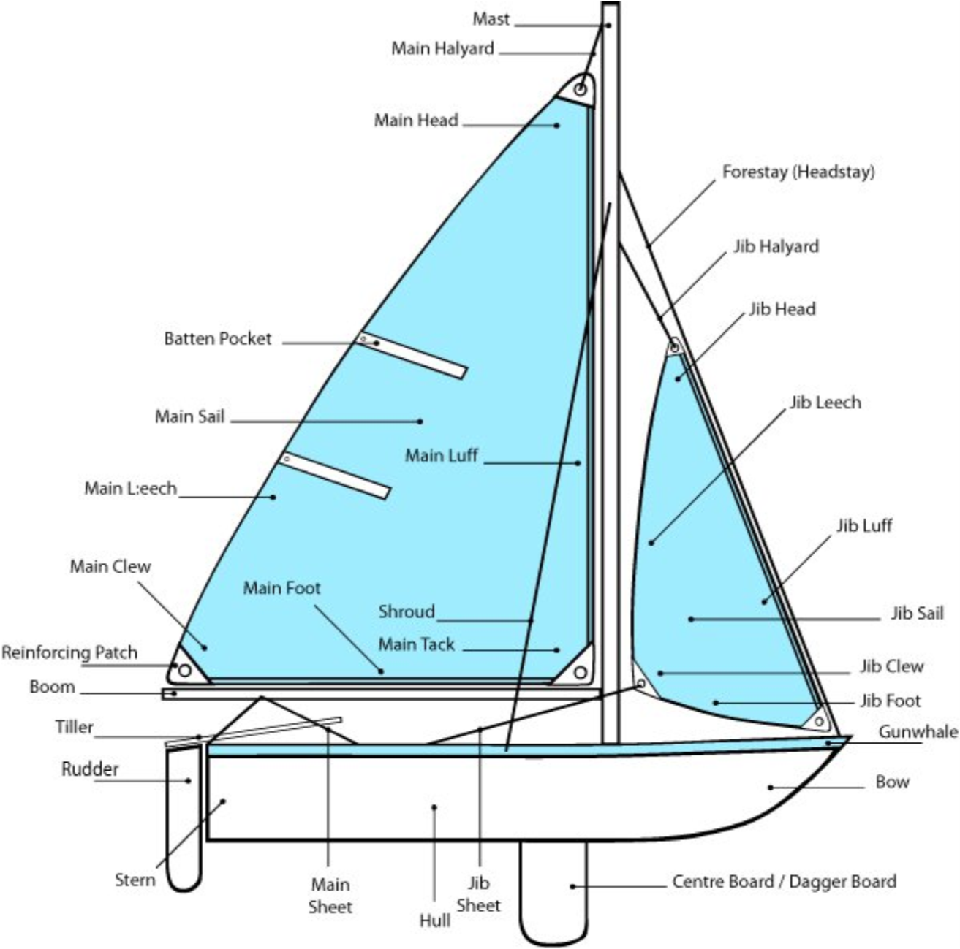

Ropework:

figure of eight knot.:
When to use it: You use it to stop a rope from slipping through a block (a pulley) or fairlead (a guide) on the boat. It's also super useful to prevent the end of a rope from fraying. figure-eight-knot

round turn and two half hitches:
When to use it: This is often used for tying a boat up to something strong, like a mooring buoy or a post on a dock, because it holds very well under strain but is still easy to undo. round-turn-two-half-hitches

Secure a rope using a Cam Cleat:
(as used on jib & main sheets)
When to use it: This is often used for tying a boat up to something strong, like a mooring buoy or a post on a dock, because it holds very well under strain but is still easy to undo.),

Can secure a rope using a Horned cleat:
(as on marinas)
You'll usually see these on marinas (docks where boats are tied up) or on bigger boats. They're used for tying up your boat securely when you're finished sailing.

Can secure a rope using a Jam cleat:
(often used on tiller to hold down rudder)
Often used on the tiller (the stick you steer with) to hold down the rudder. This can keep the rudder in a fixed position, which is handy sometimes.

Can coil a line by flaking it into one hand and secure it to stop it uncoiling.
DEMO HERE

Can throw one end of a coiled line.

Launch & Recovery: Getting In & Out of the Water!
You'll learn how to safely push and pull your boat on its trolley around the boat park, making sure you don't bump into other boats or people and watch out for overhead wires. When lifting heavier parts like the mast or even the boat itself with help, you'll learn how to work with others to lift safely. You'll be taught to always look up and be aware of any overhead wires or cables when moving your boat, as they can be dangerous. With guidance, you'll practice pushing your boat into the water from the shore or a ramp, thinking about the wind direction and how deep the water is so your rudder and daggerboard don't hit the bottom. After launching, you'll learn the best place to park your boat's trolley so it's out of the way and safe. Finally, you'll practice sailing back to your starting point and carefully guiding your boat back onto its trolley, again considering the wind to make it easy.

Sailing Techniques & Manoeuvres:

You'll gain proficiency in various sailing techniques and manoeuvres, building your confidence and control on the water.

Basic Boat Handling
- Paddling/Rowing: You'll learn to paddle or row your boat in a straight line by focusing on symmetrical strokes on both sides, keeping your gaze fixed on a distant point ahead to maintain your bearing. This is a crucial emergency skill if your sail becomes unusable (e.g., it rips) and you need to get back to shore or a safe location.
- Helm and Crew Roles: If you're in a two-person boat, it's vital that you spend equal amounts of time as both helm and crew. This is achieved by regularly switching positions during practice sessions. As helm, you'll gain a feel for steering and sail trim. As crew, you'll learn sail handling, observation, and effective communication, ensuring a well-rounded and collaborative learning experience.
- Stopping the Boat (In Irons): You'll practice how to stop the boat precisely at a chosen spot on the water using the "in irons" technique. This involves slowly turning the bow of the boat directly into the wind. As the boat points into the wind, the sails will luff (flap) and lose power, bringing the boat to a gradual stop. You'll learn to anticipate the boat's momentum and timing to halt exactly where desired.
- Getting Out of Irons and Getting Underway: You'll also learn to effectively get the boat out of irons and get underway again by sheeting in the sail and bearing away (turning the boat away from the wind). From the "in irons" position, you'll gently push the tiller to turn the bow slightly off the wind. Simultaneously, you'll trim (sheet in) the mainsheet to catch the wind, allowing the boat to gain momentum and begin sailing again.

Steering and Course Control
- Reaching (Across the Wind): You'll practice sailing fast across the wind (known as a beam reach), focusing on controlling your speed and avoiding obstacles. To achieve this, you'll trim your sail so it's full and pulling, but not so tight that it wrinkles near the mast (which indicates "stalling" and loss of power). You'll use the rudder for precise steering to navigate around markers or other boats, observing the wind's effect on your direction and adjusting your course accordingly.
- Close-Hauled Sailing: You'll learn to sail as close to the wind as possible without the sails flapping (called close-hauled). This technique is how you make progress against the wind by zig-zagging. While doing so, you'll aim to:
  - Steer a reasonably constant course: This is achieved by making small, precise adjustments to the tiller while constantly observing the wind direction and the telltales on your sail. The goal is to keep the boat's bow pointed as high into the wind as possible without the sails luffing.
  - Avoid unintended tacks: This requires constant attention to your course and wind direction. If the boat turns too far into the wind, it will "luff up" and potentially tack unintentionally. You'll learn to make immediate, corrective tiller movements to prevent this.
  - Maintain proper sheeting positions: The sails should be trimmed in tightly but not over-trimmed. You'll learn to use the telltales as visual guides – they should be streaming smoothly aft, indicating optimal airflow over the sail.
  - Keep the boat balanced: This involves using your body weight (hiking out) to counteract the force of the wind on the sails, keeping the boat flat and preventing excessive heeling (leaning).
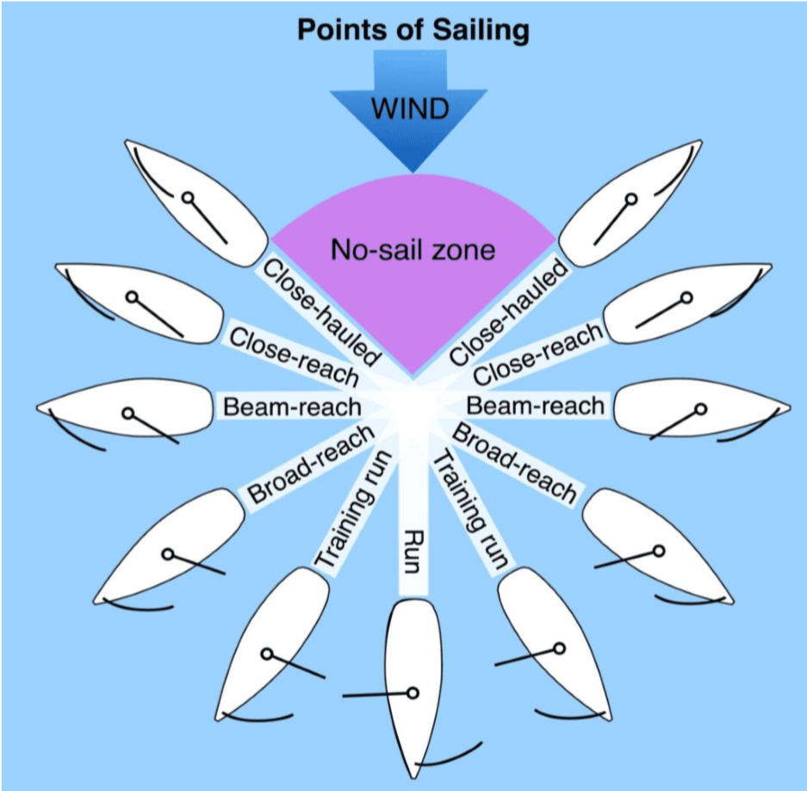

- Running (Downwind): When sailing with the wind directly behind you, known as running, you'll learn to keep the sail out wide to catch all the wind. You'll also practice sailing downwind on a training run (a broad reach but not a dead run), focusing on:
  - Steering a reasonably constant course: This can be challenging downwind as the boat can be less responsive. You'll use subtle tiller movements and observe your wake to ensure you're holding a steady line.
  - Avoiding unintended gybes: An uncontrolled gybe can be dangerous. You'll learn to anticipate wind shifts and make small course corrections to keep the wind on the desired side of the boat, preventing the boom from swinging across unexpectedly.
  - Maintain correct sail setting: The sail will be let out almost perpendicular to the boat, maximizing its exposure to the wind. You'll observe its shape and adjust for optimal drive.
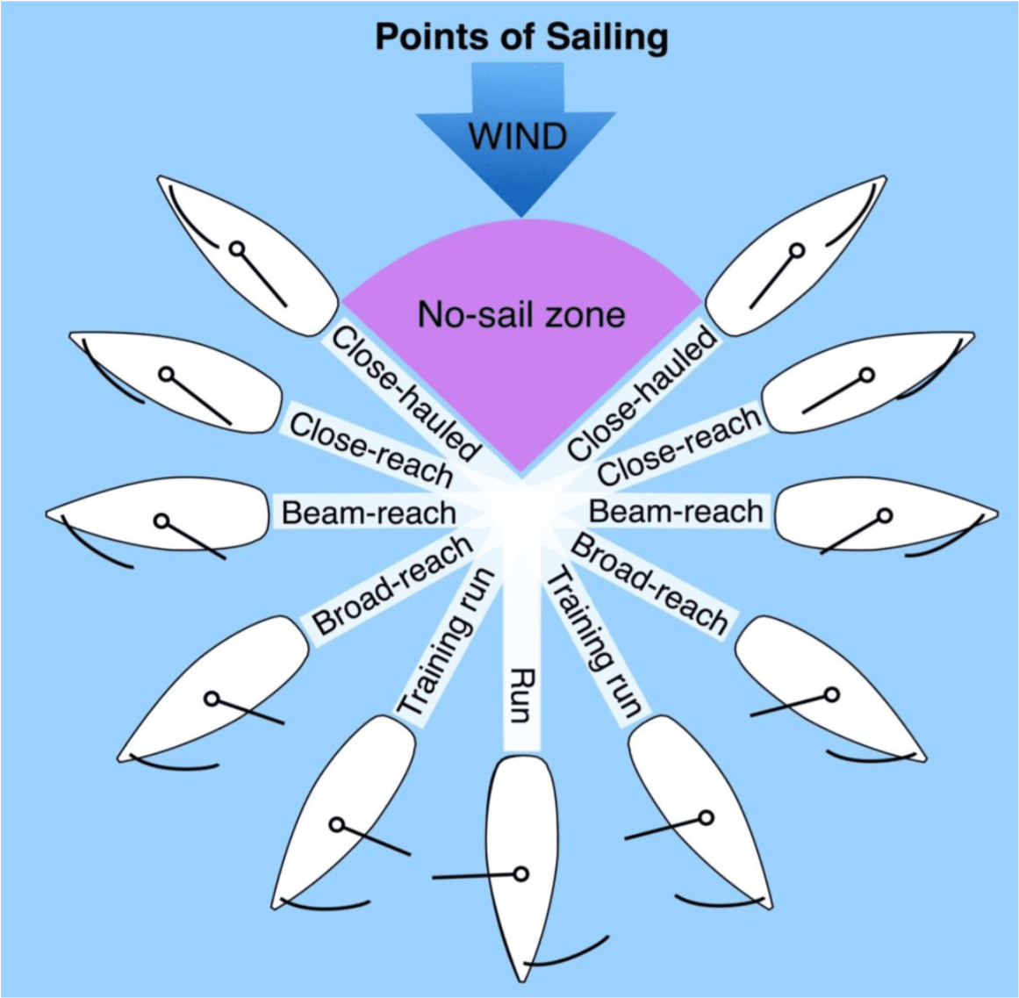
- Wind and Current Awareness: You'll begin to understand how the wind and any water currents affect your boat's movement, and how to use them to your advantage when steering to avoid obstacles. This involves observing ripples on the water, flags, and other boats to gauge wind shifts and currents. You'll then adjust your course and sail trim proactively to leverage these forces for efficient and safe navigation around markers or other vessels.

Turning Manoeuvres
- Tacking (Through the Wind): Your tacks (turning through the wind) will become smoother! You'll practice the sequence of turning the boat, moving your body across, and adjusting the sail in one fluid motion, coordinating with your crew. To achieve a smooth tack, you'll:
  - Maintain boat speed through the manoeuvre: You'll initiate the turn with good speed and release the mainsheet just enough for the sail to pass through the wind, then re-trim quickly on the new tack to maintain momentum.
  - Maintain an awareness of and avoiding other water users: Before initiating a tack, you'll perform a 360-degree scan to ensure the path is clear and communicate your intentions clearly to your crew and any nearby boats (e.g., "Ready to tack!").
  - Maintain control of the boat before, during, and after the manoeuvre: This means executing a deliberate and controlled turn with the tiller, ensuring the boat doesn't lose excessive speed or become unstable. You'll also re-balance the boat immediately on the new tack.
  - Using the tiller extension if normally fitted to your boat type: You'll learn to hold the tiller extension effectively to allow you to lean out and balance the boat while still steering.
  - Keeping your crew informed of your intentions and progress: Clear communication is key. You'll call out "Ready about!" or "Tacking!" to your crew and confirm "Tacking!" as the boat turns.
- Gybing (Through the Wind from Astern): Gybing is an new turn where you turn the back of your boat through the wind, meaning the boom will swing across the boat. You'll learn to control the smooth swing of the boom carefully, ensuring it doesn't hit anyone and that the boat remains balanced throughout the turn. It's often harder to control than a tack, especially in stronger winds. When gybing, you'll work on:
  - Maintaining boat speed through the manoeuvre: Like tacking, you'll aim to keep the boat moving well. You'll pull the mainsheet in slightly just before the gybe to control the boom's swing, then let it out quickly on the new gybe.
  - Maintaining an awareness of, and avoiding other water users: Again, a thorough scan before initiating the gybe is crucial. You'll communicate your intentions ("Ready to gybe!" or "Gybing!") to your crew and other vessels.
  - Maintaining control of the boat before, during, and after the manoeuvre: This involves a steady hand on the tiller to turn the stern through the wind. The key is to manage the boom's swing by actively sheeting the mainsheet. You'll ensure the boat doesn't heel excessively or become unstable.
  - Using the tiller extension if normally fitted to your boat type: This allows for better body position and control during the turn.
  - Keeping your crew informed of your intentions and progress: Clear commands like "Ready to gybe!" and "Gybing!" are essential for coordinated action and safety. You'll also warn your crew about the boom's swing.
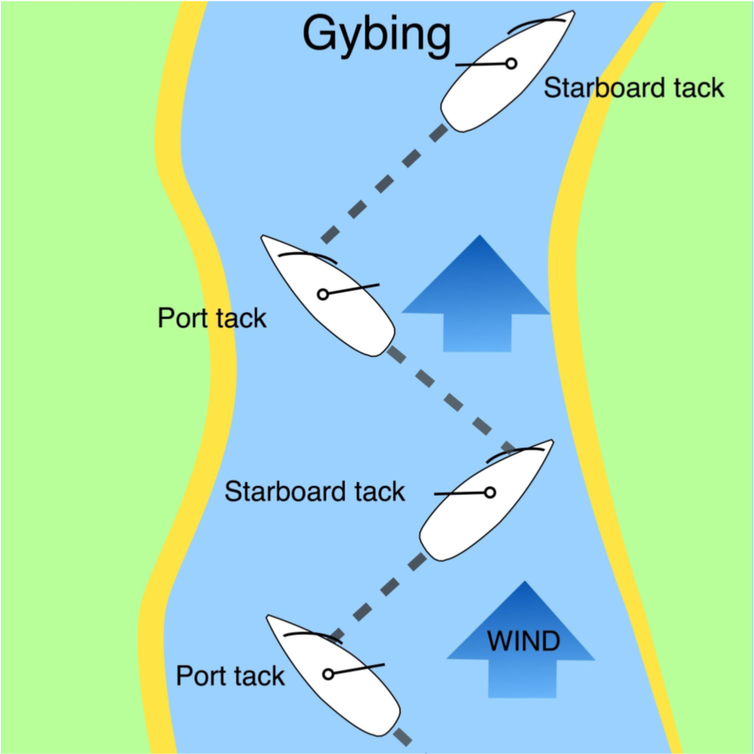

Capsize Recovery:
You'll actively practice flipping your boat back over after it capsizes and then climbing back in safely. Your instructor will guide you through the steps, which often involve getting to the daggerboard, pulling the boat upright, and then using a specific method to get back into the boat (like the "scoop” method). If the boat goes completely upside down (inverts), you'll learn how to quickly find the air pocket under the hull and safely get out from under the boat without panicking.

Sailing Knowledge:
You'll develop a strong understanding of essential sailing theory, including collision avoidance, environmental factors, and key terminology, enhancing your safety and decision-making on the water.

Points of Sailing
You'll be able to describe the different points of sailing, understanding your boat's angle in relation to the wind and how to trim your sails accordingly. You'll be able to point to diagrams or other boats and name how they are sailing in relation to the wind.
- Close-Hauled: This is the point of sailing where you are sailing as close to the wind as possible without your sails luffing (flapping). The boat will be heading approximately 45 degrees into the wind. To achieve this, your sails will be pulled in tightly, and you'll maintain precise steering and balance to keep the boat tracking efficiently "upwind" by zig-zagging (tacking).
- Beam Reach: When sailing on a beam reach, the wind is coming directly across the side of your boat (approximately 90 degrees to your boat's direction). This is often the fastest and most stable point of sailing. You'll learn to trim your sails to a moderate position, letting them out slightly from the close-hauled position to catch the wind effectively, maintaining good speed and control.
- Broad Reach (or Training Run): On a broad reach, the wind is coming from behind your boat, but still slightly to one side (e.g., 120-150 degrees off the bow). A "training run" often refers to a broad reach where the boat is heading almost directly downwind, but not quite. Your sails will be let out further than a beam reach to maximize the wind's drive. This point of sailing requires careful attention to avoid an unintended gybe, especially in stronger winds.
- Run: A run is when you are sailing directly downwind, with the wind coming from directly behind your boat (approximately 180 degrees). To achieve maximum speed and efficiency on a run, you'll let your sails out as wide as possible, often perpendicular to the boat. This point of sailing can be less stable than a reach and demands constant awareness of the wind and careful control of the boom to prevent accidental gybes.

Collision Avoidance (Rules of the Road)
- Understanding Right of Way: You'll learn the fundamental "Rules of the Road" for sailors, enabling you to take the correct action when boats on different tacks meet. This is crucial for preventing collisions.
  - Different Tacks: When two sailboats are approaching each other with the wind coming from different sides (on opposite tacks), the boat with the wind on its port (left) side must give way to the boat with the wind on its starboard (right) side. You'll practice identifying your own tack and the tack of approaching boats to determine who has right of way and execute the necessary manoeuvre (e.g., altering course or slowing down).
  - Same Tack: When two boats are on the same tack (wind coming from the same side for both), the leeward (downwind) boat has right of way. The windward (upwind) boat must give way. You'll learn to maintain situational awareness, especially when sailing parallel to other boats on the same tack, to ensure you respect the leeward boat's right of way.
  - Other Vessels: You'll also learn basic rules for interactions with powerboats, commercial vessels, and vessels constrained by their draft, understanding that they generally have less manoeuvrability than a sailboat and thus often have right of way.
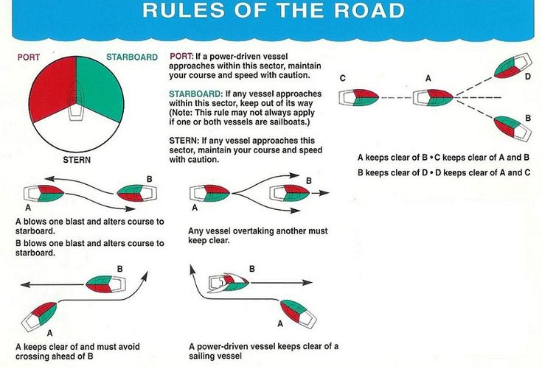

Environmental Awareness
- Tides and Currents: You'll be able to describe how tides and currents can affect them. You'll understand that the water moves in and out (tides) and sometimes flows in rivers or channels (currents), and how this moving water can push your boat around or change how fast you go. You'll learn to:
  - Identify Tidal Patterns: Recognize rising and falling tides and how they impact water depth, which is vital for safe navigation, especially near shore or in shallow areas.
  - Observe Current Effects: Spot visual clues of currents (e.g., ripples, objects moving on the water) and understand how a current can increase or decrease your boat's speed over the ground or push you off course. You'll learn to account for current when planning your route or aiming for a specific destination.

Safety Equipment
- Personal Flotation Devices (PFDs): You'll be able to identify when sailors are required to wear PFDs by law. This includes understanding local regulations and common best practices for when a PFD should be worn, such as when sailing in strong winds, cold water, or when you are a non-swimmer, or simply as a mandatory requirement by the sailing school or club. You'll also learn the importance of ensuring your PFD fits correctly and is in good condition.

Sailing Terminology
- Common Sailing Terms: You'll learn to identify and use common sailing terms accurately, both in conversation and when responding to instructions. This includes being able to point to diagrams or other boats and name how they are sailing in relation to the wind, using the correct terminology. Key terms you'll master include:
  - Sheet in: To pull the sail closer to the centreline of the boat, typically to gain power or sail closer to the wind.
  - Sheet out: To let the sail further away from the centreline of the boat, typically to reduce power or sail further downwind.
  - Luff up: To turn the boat towards the wind, causing the sails to flap and lose power.
  - Bear away: To turn the boat away from the wind.
  - Upwind: Sailing towards the direction from which the wind is blowing.
  - Downwind: Sailing in the same direction as the wind is blowing.
  - Tacking: The manoeuvre of turning the bow of the boat through the wind to change sides.
  - Gybing: The manoeuvre of turning the stern of the boat through the wind to change sides.
  - In Irons: The state where a boat is stuck directly facing into the wind, with sails luffing and unable to move forward or backward.
  - Port: The left-hand side of the boat when looking forward.
  - Starboard: The right-hand side of the boat when looking forward.
  - Bow: The front part of the boat.
  - Stern: The back part of the boat.

Coastal Knowledge: Understanding Your Environment
Understanding your coastal surroundings, particularly the dynamics of tides, is crucial for safe and efficient sailing.

Tidal Cycles
You'll learn about the regular rise and fall of the sea level, known as tides, and how they are primarily caused by the moon's gravitational pull on the Earth's oceans.
- How Often Tides Occur: You'll be able to describe how often high and low tides occur. In most coastal areas, high and low tides occur approximately twice a day. This means you will experience two high tides and two low tides within roughly a 24-hour period. Each change from a high-water mark to a low water mark (or vice-versa) takes approximately 6 hours.
- High Tide: This is when the water level reaches its highest point. At high tide, there is more water in harbours, over sandbanks, and closer to the shoreline.
- Low Tide: This is when the water level reaches its lowest point. At low tide, certain areas that were submerged at high tide may become dry, revealing rocks, sandbanks, or exposing mudflats.

Implications of Tides on Sailing Activities
You'll be able to describe the implications of tides on activities, recognizing their critical importance for safe navigation and planning:
- Access to Harbours and Slipways: Tides significantly affect your ability to launch, recover, and access certain harbours or slipways. At low tide, some areas may become too shallow to allow your boat to float, potentially leading to you getting stuck in mud or on the bottom. You'll learn to check tidal predictions to ensure sufficient water depth for your planned activities.
- Navigating Shallow Areas: Areas that appear safe to sail through at high tide can become dangerously shallow or even completely dry at low tide. This presents a significant risk of running aground (getting stuck on the seabed or a hidden obstacle). You'll learn to consult charts and tidal information to identify such areas and avoid them during low water.
- Tidal Currents: As the tide moves in and out, it creates tidal currents (moving water). These currents can have a substantial impact on your boat's speed and direction over the ground. You'll learn how a strong current can either boost your progress or slow you down, and how it can push your boat off your intended course, requiring you to adjust your steering to stay on track.
Understanding these tidal implications is essential for planning your sailing trips safely, avoiding hazards, and ensuring you can always get to and from your desired locations without incident.

Weather & Safety:
Developing a keen awareness of weather conditions and essential safety procedures is paramount for every sailor. You'll learn how different wind conditions impact your sailing activity and what steps you need to take for safety.

Understanding Wind Direction and Its Impact
You'll learn to identify the direction of the wind relative to the land and understand its significant implications for your sailing activity and safety.
- Onshore Winds:
  - Description: Onshore winds are those that blow towards the land from the water.
  - Effect on Sailing: When sailing with an onshore wind, it generally makes it easier to return to shore if you encounter difficulties, as the wind will naturally push your boat in that direction. This can be a comforting factor, particularly for beginners or when exploring new areas.
  - Safety Implication: Provides a 'safety net' pushing you towards land in case of equipment failure or exhaustion. However, you must still manage your approach to the shore to avoid hazards.
- Offshore Winds:
  - Description: Offshore winds are those that blow away from the land towards the open water.
  - Effect on Sailing: Sailing with an offshore wind means that if you lose control, break down, or become tired, the wind will push you further away from the safety of the land. This makes it significantly harder to sail or return to shore, potentially increasing the danger if you drift.
  - Safety Implication: Demands greater caution and preparedness. Always ensure your boat is in good working order and that you have a reliable means of propulsion (e.g., oars, small engine) if an offshore wind is present. It's crucial to be mindful of your ability to get back against the wind.

Understanding Wind Strength and Its Impact
You'll also learn how the strength of the wind dictates your sailing activity, and the safety measures you need to employ.
- High Winds:
  - Description: High winds refer to strong wind conditions that generate significant power in your sails.
  - Effect on Sailing: While exhilarating, high winds lead to very fast sailing and can make the boat harder to control. The increased force on the sails can cause excessive heeling (leaning over) and put strain on the boat and rigging.
  - Safety Implication: In high winds, it's often necessary to reef your sail (make it smaller) to reduce its area and thus reduce the power generated. This helps maintain control, reduces stress on the boat, and prevents capsizing. You'll learn the techniques for reefing. Sailing in high winds requires more experience and skill to manage the boat effectively and safely.
- No Wind (Calm Conditions):
  - Description: No wind, or light wind, refers to calm conditions where there is insufficient wind to propel the boat.
  - Effect on Sailing: This results in a slow, gentle day on the water, or no movement at all. While peaceful, it means your boat has little steerage way (ability to respond to the rudder) and you cannot sail to your desired destination.
  - Safety Implication: The primary safety concern in no wind is being stranded. You'll learn the importance of having alternative means of propulsion, such as paddles or oars, to get back to shore or to a more favourable wind area. While generally minimal risk for capsizing, it can lead to exposure if caught unexpectedly far from shore, emphasizing the need for contingency plans.

General Safety Practices
Beyond understanding wind conditions, you'll learn crucial safety habits:
- Shore Contact and Trip Plans: You'll understand why it's important to tell someone ashore (like family, friends, or a sailing club contact) where you're going and when you expect to be back. This is a critical safety practice. If you don't return as expected, someone will know to initiate a search or call for help, providing vital information about your last known location.
- Signalling for Help: You'll learn different ways to get help if you or someone else needs it on the water:
  - Visual Signals: Waving your arms slowly and repeatedly, raising and lowering them out to your sides.
  - Audible Signals: Using a loud whistle (distinct from recreational sounds), or other sound-producing devices.
  - VHF Radio: If you are on a safety boat or a larger vessel, you'll learn basic radio procedures to make a distress call (e.g., Mayday or Pan-Pan).
  - Other Devices: Flares (day/night), signal mirrors, or even your mobile phone in areas with coverage (though less dependable on water.

Basic Skills
Objective : By the end of this course, you will be sailing on your own in light wind conditions without assistance from your instructor. You're becoming a confident sailor!

Clothing and Equipment: Essential Preparation for Sailing
Before embarking on any sailing activity, thorough personal preparation and a complete check of your boat's equipment are fundamental for safety and enjoyment.

Personal Preparation: Clothing Choices
- Deciding What to Wear Before Going Sailing: You'll learn to decide what to wear before going sailing, making informed choices based on the expected weather conditions, water temperature, and the nature of your sailing activity. This involves:
  - Layering Strategy: Understanding the benefit of wearing multiple layers of clothing. This allows you to add or remove layers to regulate your body temperature effectively as conditions on the water can change rapidly.
  - Material Selection: Prioritizing quick drying, insulating materials (such as synthetics like fleece or polypropylene, or natural wool) which retain warmth even when wet. Crucially, you'll learn to avoid cotton, as it absorbs water and loses its insulating properties, leading to rapid heat loss.
  - Sun Protection: Recognizing the magnified risk of sunburn due to UV reflection off the water. This means actively choosing to wear sunscreen, hats with brims, and sunglasses for eye protection, even on seemingly cloudy days.
  - Appropriate Footwear: Selecting closed-toe, non-slip footwear that can get wet and provides good grip on a boat's slippery surfaces.
  - Personal Flotation Device (PFD): Ensuring you always have access to a correctly fitting PFD (lifejacket or buoyancy aid) and understanding when its wear is legally mandated in Ireland or strongly recommended for safety (e.g., strong winds, cold water, non-swimmers).

Boat Preparation: Essential Equipment and Checks
You'll develop a routine for preparing your sailing boat for use, ensuring it is properly equipped and structurally sound.
- Equipping a Sailing Boat for Use: You'll learn to equip a sailing boat for use by ensuring all necessary items are on board and correctly stowed in accessible locations. This typically includes:
  - Mandatory Safety Gear: Confirming the presence of essential safety equipment, such as a correctly sized Personal Flotation Device (PFD) for every person on board, a reliable bailing device (like a bucket or sponge) for removing any water that enters the boat, and a painter (a strong line attached to the bow for mooring or towing).
  - Sailing Specific Components: Ensuring the sails, rudder, and daggerboard/centreboard are present, correctly assembled, and ready for efficient deployment.
  - Emergency & Contingency Gear: Including a basic first-aid kit, a whistle for audible signalling, and, particularly for smaller boats, a pair of paddles or oars as an alternative means of propulsion in case of no wind or equipment failure.
- Checking Integrity of Hull, Buoyancy, Rigging, Spars & Foils: You'll learn to systematically check the integrity of the hull, buoyancy, rigging, spars & foils before every sailing trip. This detailed pre-sail inspection helps identify any potential issues that could compromise safety or performance during your time on the water:
  - Hull & Buoyancy: Conduct a thorough visual inspection of the hull for any visible cracks, punctures, dents, or signs of damage. For boats with integrated buoyancy tanks (sealed air compartments), ensure they are airtight and integral. If the boat relies on inflatable buoyancy (e.g., dinghy tubes), check for proper inflation and absence of leaks.
  - Rigging: Carefully examine all lines (including halyards for raising sails, sheets for controlling sails, and other control lines) for any signs of fraying, kinks, excessive wear, or damage. Confirm that all shackles, clips, and other connecting fittings are secure and operating smoothly.
  - Spars: Inspect the mast and boom (the main support structures for the sails, collectively known as spars) for any unnatural bends, cracks, or structural damage. Verify that all fittings attached to the spars (e.g., cleats, blocks) are tight and secure.
  - Foils: Examine the rudder and daggerboard/centreboard (the underwater components that provide steering and prevent leeway, collectively known as foils) for any cracks, chips, excessive wear, or damage. Ensure they are securely attached to the boat and can be deployed and operated smoothly without excessive play.
  - Overall Condition: Beyond these specific components, cultivate a general awareness for anything that seems loose, worn, out of place, or not functioning as expected. Addressing these minor issues ashore can prevent major problems afloat.

Rigging:
You'll be able to identify all of the parts of the boat, its rigging (all the ropes, wires, and blocks), and the sails by name and function.

Rigging the Boat for Use
- Can rig a boat for use on their own: You'll develop the proficiency to prepare a sailing boat independently for use on the water. This involves a systematic process of assembling the boat's components and setting up the rigging, ensuring everything is correctly and securely attached. This includes:
  - Assembling Mast and Boom: Attaching the mast to the boat and the boom to the mast.
  - Attaching Sails: Properly hoisting and attaching the mainsail and jib (if applicable) to their respective spars and halyards.
  - Connecting Running Rigging: Threading all sheets and control lines through their correct blocks and cleats, ensuring they run freely and are ready for adjustment.
  - Setting Foils: Inserting and securing the daggerboard/centreboard and rudder.
  - Initial Trim Settings: Setting up basic sail controls like mast rake (how much the mast leans backward or forward, influencing helm balance) and initial tension on the boom vang/kicker (a rope system that pulls the boom down, controlling leech tension), based on expected conditions.

Sail Selection and Reefing Decisions
- Can make appropriate decisions as to what sails to use or whether they should reef: You'll learn to assess the prevailing wind conditions and make informed choices about your sail plan to ensure both safety and optimal performance. This includes:
  - Sail Choice: For boats with multiple sail options (e.g., different sized jibs/mains), you'll learn when to opt for a smaller or larger sail based on wind strength.
  - Reefing Decision: Understanding the signs of needing to reef (e.g., excessive heeling, loss of control, heavy helm) and deciding when it's necessary to reduce the sail area by reefing. This decision prevents overpowering the boat and ensures a safer, more controlled sailing experience in stronger winds.

Sail Controls: The Outhaul
- Can identify effect of outhaul on the sail and its use in lighter & stronger winds: You'll understand the specific function and impact of the outhaul control line on your mainsail, and how to use it effectively in varying wind conditions:
  - Effect on Sail Shape: The outhaul pulls the foot of the mainsail along the boom. When pulled tight, it flattens the sail (removes draft from the lower part), making it less powerful. When eased, it allows the sail to become fuller, creating more power.
  - Use in Lighter Winds: In lighter winds, you'll ease the outhaul to make the sail fuller and deeper, generating maximum power to propel the boat.
  - Use in Stronger Winds: In stronger winds, you'll tension the outhaul to flatten the sail, depowering it to reduce heeling and maintain control, often in conjunction with reefing.

Reefing Techniques
- Can rig a slab or roll reef boat while on the trolley: For dinghy sailors, you'll practice and become proficient at reducing your mainsail area while the boat is safely on its launching trolley ashore. This involves either:
  - Slab Reefing: Learning the process of lowering the sail slightly, securing a new tack point, pulling down on a new clew point, and tying off the excess sail material.
  - Roll Reefing: Understanding how to use a rolling mechanism to wrap the sail around the mast to reduce its area. This shore-based practice helps you develop the memory and understanding necessary for future reefing afloat.

Ropework: Essential Knots for Sailing
Mastering fundamental knots is a vital skill for every sailor, ensuring safety, efficiency, and control when handling lines on board. You'll learn to tie critical knots and understand their practical applications.
You'll develop the practical skill to tie two essential knots, understanding their specific characteristics and when to apply them in a sailing context.

The Bowline:
  - How to Tie: You'll learn the steps to tie a Bowline reliably and efficiently, creating a secure loop at the end of a rope. https://knots3d.com/en/bowline-knot
  - Characteristics: This knot is renowned for creating a strong, non-slipping loop that will not tighten under strain. It is also relatively easy to untie even after being heavily loaded.
  - When to Use It: The Bowline is incredibly versatile and is used in a wide range of sailing scenarios where a fixed, non-slipping loop is required. Common uses include:
    - Creating a rescue line: Forming a loop to place around a person to pull them from the water.
    - Attaching halyards to sails: Securing the rope that hoists the sail to the sail's head.
    - Securing fenders: Attaching fenders to stanchions or rails to protect the boat.
    - Anywhere a secure, non-slipping loop is needed.

The Clove Hitch:
  - How to Tie: You'll learn how to tie a Clove Hitch quickly and effectively around a spar, rail, or post. https://knots3d.com/en/clove-hitch-knot
  - Characteristics: This knot is useful for making a quick, temporary attachment to a cylindrical object. It holds well when there is constant tension but can slip if the load is intermittent or if the object it's tied to is smooth.
  - When to Use It: The Clove Hitch is frequently used for:
    - Temporarily securing fenders: Attaching fenders to guardrails or stanchions.
    - Attaching a line to a mast or boom: For securing a temporary line, though care must be taken with intermittent loads.
    - As a quick temporary tie for gear: On deck or in the cockpit when a fast, easily releasable attachment is needed.

Sailing Techniques & Manoeuvres:
Building upon fundamental skills, you'll master a wider range of sailing techniques and manoeuvres, enabling precise boat handling, effective navigation in various conditions, and confident response to emergencies.

Boat Control
- Paddling/Rowing and Coming Alongside: You'll hone your ability to paddle or row a boat around a triangular course and come alongside a specific point or another boat. This involves maintaining a straight line while paddling, executing controlled turns using paddle strokes, and judging momentum to approach a target smoothly and gently alongside, ready to secure the boat.
- Precise Stopping: You'll practice stopping your boat precisely at a chosen spot. This skill involves understanding how to use the wind and your steering to progressively reduce boat speed, bringing the boat to a controlled halt exactly where intended, often by turning "in irons" or luffing sails. (fill and spill)
- Speed Control (Accelerating/Decelerating): You'll learn to actively control your boat's speed. This is achieved by adjusting your sails (trimming in to accelerate, letting out to decelerate or depower) and subtle steering adjustments. You'll understand how to generate or reduce power to sail faster or slower as needed.

The 5 Essentials:
You'll learn to describe "The 5 Essentials" and apply them to all points of sailing. These are fundamental elements that, when managed correctly, ensure efficient and controlled sailing:
- Course Made Good: This refers to the actual path your boat takes over the water, considering the effects of wind, current, and your steering. You'll learn to maintain your desired direction and adjust achieve the most efficient path towards your destination.
- Sail Setting: This involves correctly adjusting your sails (trimming in or letting out sheets, adjusting outhaul, vang, etc.) to optimize their shape and angle to the wind for maximum power and efficiency, whether sailing upwind, downwind, or across the wind.
- Boat Balance: This is about keeping the boat flat and upright. You'll learn to use your body weight (hiking out) and sail trim to counteract the force of the wind, preventing excessive heeling (leaning over) which can slow the boat down or make it difficult to control.
- Boat Trim: This refers to the fore-and-aft balance of the boat in the water, achieved by the placement of crew weight. Proper trim minimizes resistance and helps the boat perform optimally by keeping the bow and stern at the ideal depth.
- Daggerboard/Centreboard: You'll learn to adjust the depth of your daggerboard or centreboard. Lowering it fully provides maximum lateral resistance for sailing efficiently upwind, preventing leeway (sideways drift). Raising it partially or fully reduces drag when sailing downwind, allowing for greater speed. You'll continuously apply these principles to optimize your boat's performance on every point of sailing.

Core Sailing Manoeuvres
- Reaching, Upwind, and Downwind Sailing: You'll reinforce your ability to reach across the wind, sail upwind (close-hauled, zig-zagging against the wind), and sail downwind (running or on a broad reach). This involves consistent course keeping, appropriate sail trim for each point of sailing, and maintaining boat balance.
- Tacking and Gybing: Your turns, both tacking (turning into the wind) and gybing (turning away from the wind), will become effortless and controlled. You'll focus on executing these manoeuvres with smooth, coordinated movements between helm and crew, making your boat appear to turn gracefully. You'll ensure boat speed is maintained through the manoeuvre, maintain awareness of other water users, and maintain control before, during, and after the turn, coordinating with your crew.
- Heaving To: You'll learn the technique to heave to, which is a method of effectively stopping the boat while maintaining some steerage. This involves sheeting the jib to windward and having the rudder turned to leeward, allowing the boat to drift slowly sideways, providing a stable platform for a break, consultation, or to wait out a squall.
- Sailing Under Jib Only: You'll learn the technique of sailing under jib only. This involves lowering or furling the mainsail and using only the smaller jib to propel the boat. This can be useful in very strong winds when the mainsail is too powerful (coming ashore with an onshore breeze) or if the mainsail or its rigging is damaged.

Docking and Mooring
- Leaving and Returning to a Beach or Slipway (Light Winds): As both helm and crew, you'll practice how to leave and return to a beach or slipway in the prevailing wind direction in light winds. This involves understanding how to manage the boat's momentum, steer gently away from or towards the shore, and handle the sails efficiently for a smooth departure or arrival without power.
- Landing on a Beach or Slipway (Various Wind Conditions): You'll gain a detailed understanding of how to land on a beach or slipway effectively and safely when the wind is:
  - Offshore: Approaching with more sail area, using the wind to push you in, but controlling speed carefully.
  - Cross-shore: Using controlled turns and potentially a "ferry glide" (crabbing sideways) to offset the wind's push.
  - Onshore: Approaching with minimal speed, possibly depowering sails early (jib only if needed), and using the wind to bring you to a gentle stop against the shore. You'll learn to anticipate the wind's effect on your approach and adjust accordingly.
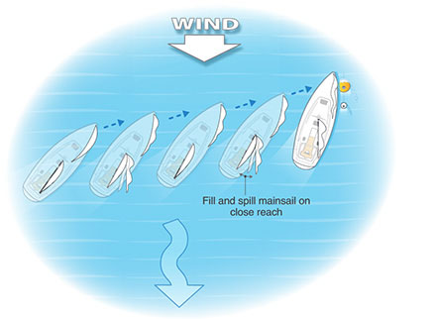
- Picking Up and Leaving a Mooring: You'll learn the steps to safely pick up and leave a mooring buoy. This involves precise boat handling to approach the buoy, secure your boat to it using a painter or mooring line (round turn 2 half hitches), and then smoothly sail away from it when ready, coordinating sail trim and steering to clear the buoy and other vessels.

- Coming Alongside and Leaving Piers/Pontoons (Head to Wind): You'll practice how to come alongside and leave a boat, pier, or pontoon that is head to wind (i.e., the wind is blowing directly off the dock/boat). This involves approaching slowly, using the wind to help you slow down, and then powering away directly into the wind for departure. (same approach as mooring)
- Coming Alongside and Leaving Piers/Pontoons (Not Head to Wind): You'll also learn to come alongside and leave a pier or pontoon that is not head to wind (e.g., cross-shore or stern-to-wind). This requires more control of boat momentum, wind effects, and sail trim to execute controlled approaches and departures, using careful steering to offset the wind.

Man Overboard Recovery:
This is a crucial safety skill. If someone falls out of the boat (man overboard), you'll learn a quick and safe way to turn your boat around and get them back on board. This involves executing a specific manoeuvre aimed at getting back to the person as fast as possible and safely alongside for recovery. You'll also practice the steps for recovery (e.g., getting a line to the person, assisting them back into the boat).


Capsize Recovery:
You'll become an expert at righting a capsized boat using a special technique called the "scoop method," where the helm (steerer) and crew (sail helper) work together to get the boat back upright efficiently. You'll get more detailed instructions on what to do if your boat goes completely upside down (inverts), including how to find an air pocket under the hull and safely get out from under the boat. You'll also practice getting the daggerboard down if it's stuck.
Here's the re-written "Sailing Knowledge" section, incorporating the new guidelines and providing detailed descriptions:

Sailing Knowledge: Principles of Sail Trim and Collision Avoidance
Developing a deeper understanding of the physics of sailing and the maritime "Rules of the Road" is crucial for enhancing your performance, ensuring safety, and navigating responsibly alongside other water users.

How Your Boat Moves
- Can describe how a sail works: You'll discover the fundamental science behind how sails propel a boat. Like an airplane wing, a sail primarily creates lift (a pulling force) rather than just being pushed by the wind. You'll learn:
  - Lift Generation: As wind flows over the curved surface of the sail, it creates higher pressure on one side and lower pressure on the other. This pressure difference generates a powerful lifting force that pulls the boat forward, not just pushes it from behind...
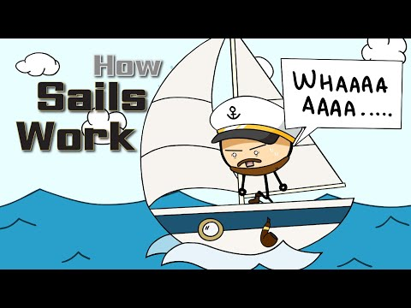

- Can describe how a centre / dagger board works: You'll understand the vital role of the centreboard or daggerboard in your boat's performance, particularly when sailing upwind.
  - Function: This movable fin extends beneath the hull into the water. Its primary function is to resist the sideways force of the wind on the sails, preventing the boat from being pushed sideways (called leeway).
  - Enabling Upwind Sailing: By providing lateral resistance, the centreboard/daggerboard allows the boat to convert the forward component of the sail's lift into efficient forward motion, enabling you to sail effectively towards the wind (close-hauled). Without it, the boat would simply be blown sideways.
  - Adjusting for Conditions: You'll also learn how to adjust its depth – typically fully down for upwind sailing, and partially or fully up for downwind sailing to reduce drag.

Collision Avoidance: Rules of the Road
Understanding and applying the maritime "Rules of the Road" is paramount to preventing collisions and ensuring safe navigation.
- Can tell if risk of collision exists between two boats: You'll develop the crucial ability to quickly assess whether a risk of collision exists between your boat and another vessel. The key indicator is if the bearing to the other vessel remains constant while the range (distance) is decreasing. If you observe another boat remaining in the same relative position on your horizon (e.g., always appearing off your port bow) but getting closer, a collision risk exists, and immediate action is required.
- Can describe what should happen when: You'll learn the specific "Rules of the Road" governing interactions between different types of vessels and between sailboats in various scenarios:
  - A motorboat and sailing boat meet: Generally, a power-driven vessel (motorboat) must give way to a sailing vessel under sail. However, a sailing vessel should not impede the safe passage of a large vessel restricted in its ability to manoeuvre (e.g., a commercial ship in a narrow channel).
  - Two sailing boats on the same tack meet: When two sailing boats are on the same tack (meaning the wind is coming from the same side for both boats), the leeward boat (the one further downwind) has the right of way. The windward boat (the one further upwind) must keep clear. You'll learn to actively identify your position relative to other sailboats on the same tack to determine who is the stand-on vessel (maintains course and speed) and who is the give-way vessel (takes avoiding action).
  - Boats are being overtaken: Any vessel overtaking another vessel is the give-way vessel, regardless of type. The vessel being overtaken is the stand-on vessel. You'll learn that the overtaking vessel must keep clear of the vessel being overtaken until it is past and clear. This rule applies equally to sailboats overtaking other sailboats, or powerboats overtaking sailboats, etc.

Coastal Knowledge: Understanding Tides and Tidal Streams
Understanding tidal patterns and the movement of tidal waters is fundamental for safe and efficient coastal sailing. You'll learn to interpret tidal information and estimate tidal flow to make informed decisions.

Understanding Tides
- Can identify when high and low tide occur using local tide tables: You'll learn how to interpret local tide tables to accurately determine the times of high and low water in your specific sailing area. You'll understand how to read the tables to find the predicted heights of the tide and the times at which high and low water will occur on any given day. This enables you to plan your sailing activities to coincide with favourable water depths, avoid grounding in shallow areas, and ensure access to harbours and slipways.

Understanding Tidal Streams
- Can describe how to estimate the rate and direction of the flow of tide and describe the effect that this might have on a sailor: You'll learn how to estimate the rate (speed) and direction of the tidal stream (the horizontal movement of water caused by the tides). This is crucial because tidal streams can significantly affect your boat's speed and direction over the ground.
  - Estimating Rate and Direction: You'll learn to use tidal stream atlases, charts, and local knowledge to predict the direction and speed of the tidal stream at various times and locations. You'll understand how the tidal stream changes throughout the tidal cycle and in different areas. (Rule of twelfths)
  - Effect on a Sailor: You'll understand how a favourable tidal stream can significantly increase your boat's speed towards your destination, while an opposing tidal stream can slow you down or even push you backwards. You'll learn how to factor the tidal stream into your navigation to make accurate course corrections, avoid being set off course, and time your passages to take advantage of favourable flows.

Weather: Understanding Conditions for Safe Sailing
Developing a comprehensive understanding of weather elements is crucial for anticipating conditions and planning safe sailing activities. You'll learn to interpret weather data and apply it to your time on the water.

Understanding Weather Elements and Their Impact
Can describe how wind speed is measured and how it may affect a sailor: You'll learn that wind speed is commonly measured in knots (nautical miles per hour), kilometres per hour (Kph), or described using the Beaufort scale.
Force / Warning | Short Description | Specifications for use on Sea | Wave height(metres) | Wind speed 10m above ground
 |  |  |  | Knots | km/h
0 | Calm | Smoke rises vertically |  | < 1 | < 1
1 | Light air | Ripples | 0.1 (0.1) | 1–3 | 1–5
2 | Light breeze | Small wavelets | 0.2 (0.3) | 4–6 | 6–11
3 | Gentle breeze | Large wavelets, crests begin to break | 0.6 (1) | 7–10 | 12–19
4 | Moderate breeze | Small waves, becoming larger; fairly frequent white horses | 1 (1.5) | 11–16 | 20–28
5 | Fresh breeze | Moderate waves, taking a more pronounced, longer form; many white horses are formed. Chance of some spray | 2 (2.5) | 17–21 | 29–38
6 | Strong breeze | Large waves begin to form; the white foam crests are more extensive everywhere. Some spray | 3 (4) | 22–27 | 39–49
7 | Near gale | Sea heaps up and white foam from breaking waves begins to be blown in streaks along the direction of the wind | 4 (5.5) | 28–33 | 50–61
8 | Gale | Moderately high waves of greater length; edges of crests begin to break into spindrift. The foam is blown in well-marked streaks | 5.5 (7.5) | 34–40 | 62–74
9 | Strong gale | High waves. Dense streaks of foam along the direction of the wind. Crests of waves begin to topple, tumble and roll over | 7 (10) | 41–47 | 75–88
10 | Storm | Very high waves with long overhanging crests. The resulting foam, in great patches, is blown in dense white streaks, along the direction of the wind. The whole surface of the sea takes on a white appearance. Visibility affected | 9 (12.5) | 48–55 | 89–102
11 | Violent storm | Exceptionally high waves (small and medium ships might be, for a time, lost to view behind the waves). The surface is covered with long white patches of foam lying along the direction of the wind. Everywhere, the edges of the wave crests are being blown into the froth. Visibility affected | 11.5 (16) | 56–63 | 103–117
12 | Hurricane | The air is filled with foam and spray. Sea completely white with driving spray. | 14 (-) | 64> | 73>

  - Measurement: You'll understand the relationship between these units (e.g., 1 knot ≈ 1.85 Kph). The Beaufort scale provides a descriptive measure of wind strength based on observed effects on the sea and land (e.g., Force 2: light breeze, ripples; Force 5: fresh breeze, moderate waves, whitecaps).
  - Effect on Sailor: Wind speed directly impacts your boat's performance and handling. Higher wind speeds mean faster sailing but also increased heel (leaning), greater demands on steering, and a higher risk of capsizing if not managed correctly (e.g., through reefing). Very low wind speeds mean slow progress or being becalmed.
- Can describe how wind direction is measured and how it may affect a sailor: You'll learn that wind direction is measured using compass headings (e.g., from the North, South-West, etc.). You'll also understand its critical implications based on its relation to the land:
  - Onshore Winds: These blow towards the land from the water. They generally provide a 'safety net', pushing you towards shore if you have difficulty. However, they can also create choppy conditions near the coast and make landing more challenging.
  - Offshore Winds: These blow away from the land towards the open water. They present a significant safety concern as they can push you further offshore if you lose control or suffer equipment failure, making it harder to return to safety. They often create flatter water closer to shore.
  - Effect on Sailor: Wind direction dictates your boat's course relative to the wind (points of sailing) and influences tactics for leaving and returning to shore and managing waves.
- Can describe how visibility is measured and how it may affect a sailor: You'll learn that visibility is measured in nautical miles or meters.
  - Effect on Sailor: Reduced visibility significantly increases the risk of collision.
  - Hazards associated with fog: Fog is a common cause of severely reduced visibility. In fog, it becomes extremely difficult to see other vessels, navigation marks, or land. This necessitates slowing down, making sound signals (e.g., foghorn), and relying more on compass bearings and charts, as well as keeping a vigilant lookout for hazards.
- Can describe how temperature is measured and how it may affect a sailor - Actual and effects of wind chill: You'll understand the importance of air and water temperature and the concept of wind chill.
  - Actual Temperature: This is the ambient air temperature, measured in Celsius. Water temperature is also vital, especially for immersion.
  - Wind Chill: This is the apparent temperature felt on exposed skin due to the combined effect of air temperature and wind speed. Even on a moderately cold day, a strong wind can make it feel much colder, significantly increasing the risk of cold-related injuries.
  - Effect on Sailor: Low temperatures and wind chill can lead to rapid heat loss from the body, increasing the risk of hypothermia (dangerously low body temperature). This necessitates appropriate clothing choices (layers, waterproofs), and awareness of how quickly conditions can lead to cold stress.
- Can obtain a weather forecast for a sailing area and describe how it might affect their planned activities: You'll learn to actively seek out and interpret reliable weather forecasts for your specific sailing area.
  - Sources: You'll know where to find forecasts (e.g., reputable marine weather websites and apps, marine radio broadcasts, local sailing club boards, or your instructors).
  - Application to Planning: You'll learn to analyse key elements of the forecast (wind speed/direction, visibility, temperature, precipitation) and describe how they might affect your planned activities, such as:
    - Deciding whether to sail at all.
    - Choosing appropriate sail area (e.g., reefing).
    - Planning your route to take advantage of or mitigate wind/tide effects.
    - Selecting suitable clothing and safety equipment.
    - Adjusting your expected return time.

Safety: Essential Practices and Emergency Response
Beyond understanding weather, safety practices and the ability to respond effectively in emergencies are fundamental responsibilities for every sailor.

Pre-Sailing Safety Planning
- Can explain the importance of telling someone where they are going and when they will be back: You'll understand in detail why it is super important to always tell someone ashore (like your instructor, family, or a sailing centre contact) where you're going sailing and when you expect to be back. This is known as leaving a "passage plan" or "shore contact details."
  - Importance: This is a crucial safety rule because if you don't return as expected, someone will know to raise an alert. They will have vital information about your intended route, destination, and expected return time, significantly aiding any potential search and rescue efforts. It ensures that help can be summoned promptly if you encounter unforeseen difficulties.

Emergency Equipment and Care
- Can describe how to use and care for distress flares: You'll learn about several types of distress flares (e.g., handheld red flares for close-range signalling, parachute flares for long-range visibility) and understand their purpose as visual emergency signals.
  - Use: You'll learn the proper procedure for deploying flares safely according to their instructions, emphasizing pointing away from yourself and others, and ensuring they are visible to potential rescuers.
  - Care: You'll understand the importance of storing flares in a dry, accessible location, checking their expiry dates (as they must be in date to be legally carried and effective), and disposing of expired flares responsibly.

Main Types of Distress Flares (Commonly Carried on Boats):
- Red Handheld Flare:
  - Appearance: A cylindrical tube, often with a handle. When activated, it produces a bright, steady red flame.
  - Purpose: Short-range distress signal, primarily for pinpointing your location to rescuers who are already in sight or relatively close. It's used to show your exact position.
  - Burn Time: Typically burns for about 60 seconds.
- Red Parachute Flare (Rocket Flare / Red Star Signal):
  - Appearance: A larger, rocket-like tube. When activated, it fires a projectile high into the air.
  - Purpose: Long-range distress signal. The projectile deploys a flare on a small parachute at altitude, which burns brightly as it descends slowly. This is used to attract attention from a significant distance (e.g., to distant ships, aircraft, or shore stations).
  - Altitude: Can reach 300 meters (approx. 1000 feet) or more.
  - Burn Time: Typically burns for about 40-60 seconds.
- Orange Smoke Signal (Handheld or Floating):
  - Appearance: A cylindrical canister. When activated, it produces dense orange smoke. Can be handheld or designed to float on the water.
  - Purpose: Daytime distress signal. The vivid orange smoke is highly visible against the sky or water, especially from aircraft or boats during daylight hours.
  - Burn Time: Typically produces smoke for 60-120 seconds.
4. White Handheld Flare (or White Collision Warning Flare):
- Appearance: Like a red handheld flare, a cylindrical tube that produces a bright white flame.
- Purpose: Not a distress signal. Instead, white flares are used as a collision warning signal or for illumination.
  - Collision Warning: If you believe another vessel is on a collision course with you and doesn't seem to be taking appropriate avoiding action (especially at night or in low visibility), a white flare can be used to attract their attention and warn them of your presence or danger. It's a "warn-off" signal.
  - Illumination: They can also be used to briefly illuminate an area, for example, to get a better look at a navigation mark, a mooring buoy, or a person in the water at night. This is particularly useful in an emergency like a man overboard at night, to help a searchlight locate the person.

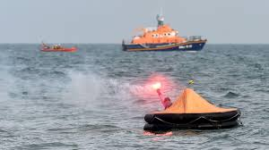
- Burn Time: Typically burns for about 60 seconds.

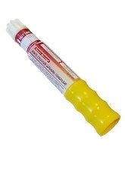

Emergency Care
- Can describe how to care for someone who is very cold: You'll learn to recognize the signs of hypothermia (dangerously low body temperature), such as shivering, confusion, slurred speech, and clumsiness. You'll then learn simple yet effective ways to help someone who is very cold:
  - Remove Wet Clothing: Get them out of any wet clothes immediately.
  - Insulate and Warm: Wrap them in dry blankets, sleeping bags, or foil emergency blankets to prevent further heat loss and begin warming them slowly.
  - Provide Warmth (if conscious): Offer warm, sweet drinks (non-alcoholic) to help warm them from the inside. Avoid rubbing their limbs.
  - Seek Professional Help: Always monitor their condition and seek professional medical attention as soon as possible.
- Can explain why it is important for a sailor to have some training in Emergency Care: You'll understand that having some basic training in Emergency Care (First Aid) is incredibly helpful for sailors.
  - Preparedness: Minor cuts, scrapes, sprains, or even more serious incidents can occur while sailing. Basic first aid knowledge empowers you to confidently manage common injuries and illnesses.
  - Bridging the Gap: On the water, professional medical help may not be immediately available. Emergency care training enables you to provide immediate assistance, stabilize a casualty, and potentially prevent a situation from worsening while awaiting professional medical attention.

What Next?
You'll get advice on how to continue sailing and improve your skills even further after finishing this course, perhaps joining a racing club or exploring new sailing areas.

Improving Skills

Objective: To develop the skills and knowledge you need to set up and sail the boat more effectively and in moderate conditions. This course will also prepare you for the specialist courses ahead.
You'll become a truly independent and skilled sailor!

Rigging and Boat Care:
At this level, you'll demonstrate confident and correct independent rigging, along with thorough de-rigging and comprehensive boat care practices, ensuring optimal performance and longevity of your vessel and equipment.

Rigging Your Own Boat
- Can rig their own boats: You will learn to confidently and correctly rig your boat all by yourself, without supervision. This involves mastering the entire process from start to finish, ensuring every component is properly assembled and secured. Your rigging will not just be functional but optimized for the specific wind and water conditions of the day. This means you'll be able to make informed decisions on:
  - Boom Vang/Kicker Tension: Adjusting the downward pull on the boom to control mainsail shape and twist, crucial for different wind strengths.
  - Halyard and Sheet Leads: Ensuring all lines run freely through their blocks and are correctly cleated, ready for immediate and precise adjustment.
  - Foil Settings: Inserting and securing the daggerboard/centreboard and rudder and knowing the initial setting for the conditions. You'll understand how these adjustments influence sail shape, boat balance, and overall performance, enabling you to get the best out of your boat in any given condition.

De-Rigging and Post-Sailing Care
- Can de-rig the boat: You'll learn to competently and efficiently de-rig the boat. This involves:
  - Lowering and Removing Sails: Safely bringing down the sails from the mast and boom.
  - Disassembling Rigging: Carefully disconnecting and disassembling the mast, boom, and other rigging components.
  - Securing Equipment: Ensuring all loose equipment is accounted for and stored securely in its designated place to prevent loss or damage.
- Care for sails by washing, drying, folding/rolling up and stowing in sail bags: You will master the proper care of your sails to maintain their condition and extend their lifespan. This includes:
  - Washing: Rinsing sails thoroughly with fresh water to remove salt, dirt, and grime.
  - Drying: Ensuring sails are completely dry before storage to prevent mildew, rot, and fabric degradation. This often involves hanging them in a well-ventilated area.
  - Folding/Rolling Up: Learning specific techniques for neatly folding or rolling sails to minimize creasing and preserve their shape.
  - Stowing in Sail Bags: Correctly placing dried and folded/rolled sails into their protective sail bags for storage, shielding them from UV damage and contaminants.
- Care for hull by washing, bailing, drying, fitting covers: You'll undertake thorough care for your boat's hull to protect its integrity and appearance:
  - Washing: Rinsing the hull and deck with fresh water immediately after sailing to remove salt and prevent buildup.
  - Bailing: Removing any accumulated water from the cockpit or bilge.
  - Drying: Wiping down the interior and exterior to prevent mildew and spotting.
  - Fitting Covers: Correctly fitting covers (e.g., top covers, cockpit covers) to protect the boat from UV exposure, rain, and debris when not in use.
- Check for damage, tidy sheets and lines, and secure equipment: As part of your routine, you will always check for damage on the hull, rigging, spars, and foils (daggerboard/centreboard and rudder) during de-rigging and cleaning. You will meticulously tidy all sheets and lines by coiling them neatly and hanging or stowing them correctly to prevent tangles and prolong their life. Finally, you will secure all equipment, ensuring everything is safely put away or tied down, leaving the boat clean, organized, and ready for its next use or storage.
.

Tuning:
At this level, you'll develop the advanced skills to fine-tune your boat and its rigging, maximizing its speed, efficiency, and pointing ability across a range of wind and water conditions. This involves understanding and expertly using various sail and rig controls.

Key Tuning Controls and Their Use
You will be able to identify and demonstrate / describe the use of the following to optimise a boat / rig for a particular set of conditions:
- Sail Telltales: These are small pieces of yarn attached to both sides of your sails (mainsail and jib).
  - Use: You'll learn to interpret their behaviour as critical indicators of wind flow over the sail surfaces.
    - When both windward and leeward telltales are streaming smoothly aft, it indicates optimal, attached airflow and maximum lift.
    - If the windward telltale flutters, the sail is luffing too much (boat is too high or sail is too far out).
    - If the leeward telltale flutters, the sail is stalled (boat is too low or sail is trimmed too far in).
  - Optimisation: You'll use telltales to guide adjustments to your course and sail trim (e.g., sheeting in or out) to maintain smooth airflow and maximize power
- Outhaul: This control adjusts the tension along the foot of the mainsail.
  - Use: It pulls the clew (aft corner) of the mainsail towards the end of the boom.
  - Effect: Tightening the outhaul flattens the mainsail, reducing draft (depth) and power. Easing the outhaul allows the sail to become fuller and deeper, increasing power.
  - Optimisation: In lighter winds, you'll ease the outhaul to create a fuller sail, generating more power. In stronger winds, you'll tension the outhaul to flatten the sail, depowering it to reduce heel and improve control.
- Kicker or Vang: This is a rope system (usually a block and tackle) that pulls the boom downwards, preventing it from lifting too high.
  - Use: It controls the vertical position of the boom and, crucially, affects the tension of the mainsail's leech (the aft edge).
  - Effect: Applying tension to the kicker/vang tightens the leech, increasing its curvature and potentially inducing more twist (the difference in angle between the top and bottom of the sail). When sailing off the wind (reaching or running), the kicker/vang becomes the primary control for leech tension, as the mainsheet is eased out.
  - Optimisation: In moderate to strong winds, particularly off the wind, you'll apply kicker/vang tension to prevent the boom from rising and the leech from twisting excessively, keeping the mainsail powerful and driving. In light winds upwind, you might ease the kicker/vang to allow more leech twist, which can help the top of the sail catch more wind.
- Halyard Tension: This refers to the tension applied to the rope (halyard) that hoists the sail up the mast.
  - Use: It controls the tension along the luff (leading edge) of the sail.
  - Effect: Increasing halyard tension removes horizontal wrinkles from the luff, moving the draft (fullest part of the sail) forward. Easing tension allows horizontal wrinkles to form, moving the draft aft.
  - Optimisation: In stronger winds, more halyard tension flattens the entry of the sail, making it less powerful and reducing heel. In lighter winds, slightly less tension allows the luff to be fuller, creating more power.
- Cunningham / Downhaul: This control pulls the luff of the mainsail downwards, often at the tack (forward-lower corner).
  - Use: It directly impacts the position of the maximum draft in the mainsail.
  - Effect: Applying Cunningham/downhaul tension moves the draft forward in the sail and flattens it. This creates a smoother entry for the airflow.
  - Optimisation: In stronger winds, you'll pull on the Cunningham/downhaul to flatten the sail and move the draft forward, depowering the sail and improving pointing ability. In lighter winds, you'll ease it to allow the draft to move aft and the sail to become fuller, creating more power.
- Jib Sheeting Angles: This involves adjusting the position of the jib sheet fairlead (the block through which the jib sheet passes) along the boat's deck.
  - Use: It controls the angle at which the jib sheet pulls on the sail, thus shaping the jib.
  - Effect: Moving the fairlead forward closes the leech of the jib, making it fuller at the top. Moving it aft opens the leech, flattening the top.
  - Optimisation: The goal is to ensure the jib telltales break evenly and that the jib's leech works effectively with the mainsail (the "slot effect"). You'll adjust for optimal shape for pointing and power in various wind strengths.
- Main Sheet Traveller: Found on many dinghies and keelboats, this allows the mainsheet block to move from side to side across the boat.
  - Use: It controls the boom's lateral position relative to the boat's centreline, independently of the mainsheet tension (which primarily controls leech tension and sail twist).
  - Effect: Moving the traveller to windward allows you to sheet the boom closer to the centreline without over-tightening the mainsheet, which can stall the sail. Moving it to leeward opens the leech.
  - Optimisation: You'll use the traveller to maintain optimal boom angle and mainsail trim in varying wind conditions, allowing you to keep the sail powered and the boat balanced. In moderate to fresh winds, you can ease the mainsheet slightly to depower the sail and maintain control, while keeping the boom centred with the traveller.

Optimising Performance Across Conditions
- Can use boat and rig controls to optimise the performance of a boat in a variety of conditions including light, medium and moderate wind conditions and on all points of sailing: You'll develop the practical skill of integrating all the above controls to continuously optimize your boat's performance. This means you'll:
  - Continuously Observe: Read the wind, water, and sail telltales.
  - Anticipate and React: Understand how each control influences the boat's speed, pointing ability, and balance.
  - Adapt Trim: Consistently adjust halyard tension, Cunningham/downhaul, outhaul, kicker/vang, jib sheeting angles, and main sheet traveller settings to achieve peak performance in light winds (maximizing power and depth), medium winds (balancing power and control), and moderate winds (depowering and flattening for control and pointing).
  - Apply to All Points of Sailing: Master these adjustments for sailing upwind (close-hauled, optimizing pointing and CMG), across the wind (reaching, maximizing speed), and downwind (running/broad reaching, optimizing drive and stability). Through this continuous process of observation and adjustment, you'll make your boat sail as fast and efficiently as possible, adapting to every change in conditions.

Boat Handling: Advanced Manoeuvres and Independent Control
At this advanced level, you'll develop exceptional control over your boat, executing complex manoeuvres with precision and confidence across a wider range of conditions. Your aim is to become highly independent and effective in all aspects of boat handling.

Advanced Turns: Tacking and Gybing
- Can tack effectively in all wind conditions: You will achieve mastery in tacking (turning the bow through the wind). This involves executing quick, smooth, and controlled tacks that minimize loss of speed, not just in light or medium winds, but effectively in all wind conditions, including stronger winds. You'll demonstrate precise timing and coordinated movements between helm and crew to maintain momentum and control throughout the manoeuvre.
- Can gybe effectively in all wind conditions: Similarly, you will achieve mastery in gybing (turning the stern through the wind). You'll perform smooth, quick, and controlled gybes, even in challenging conditions or stronger winds, ensuring the boom crosses safely and the boat remains stable. This requires precise timing and coordinated movements between helm and crew to manage the sail and maintain control.
- Can perform a basic roll tack in light wind conditions: You'll learn and practice the technique of a basic roll tack specifically in light wind conditions. This advanced technique uses body weight (a "roll") to help the boat turn more efficiently and carry momentum through the tack, minimizing speed loss when there's not much wind to push the boat around.
- Can perform a basic roll gybe in light wind conditions: You'll also learn and practice a basic roll gybe in light wind conditions. Like the roll tack, this technique uses body weight to help the boat complete the gybe smoothly and maintain speed in minimal wind, making the manoeuvre more effective and less prone to stalling.

Precise Docking and Mooring
- Pick up a mooring in moderate conditions and with little or no assistance from the instructor: You will become highly skilled at approaching and picking up a mooring buoy. You'll demonstrate the ability to pick up a mooring in moderate conditions with excellent precision, requiring little or no assistance from the instructor. This involves judging your approach speed and angle, using sail and rudder to slow and position the boat accurately, and then securing the boat to the mooring buoy efficiently.
- Safely approach, come alongside and leave a pier or pontoon allowing for wind and current in moderate conditions and with little or no assistance from the instructor: You'll refine your ability to safely approach, come alongside, and leave a pier or pontoon, demonstrating proficiency in moderate conditions and requiring little or no assistance from the instructor. This encompasses:
  - Allowing for Wind and Current: Accurately assessing and compensating for the effects of both wind and current on your boat's approach and departure.
  - Precise Positioning: Using subtle sail adjustments and rudder control to achieve a gentle, controlled arrival alongside the pier or pontoon, regardless of the wind direction relative to the dock.
  - Controlled Departure: Executing smooth and efficient departures, understanding how to use the wind and initial boat momentum to safely clear the dock and other obstacles.

Specialized Manoeuvres and Control
- Sail effectively under jib only in moderate conditions: You'll learn to sail effectively under jib only in moderate conditions. This skill is valuable in situations where the mainsail might be too powerful (e.g., very strong winds), or if the mainsail is damaged. You'll demonstrate how to control the boat's course, manage its speed, and even perform basic turns using only the jib and rudder.
- Can describe the principles of sailing without a rudder and sail a beam reach without a rudder: This demonstrates a deep understanding of boat control. You'll be able to describe the principles of sailing without a rudder, explaining how sail trim (main sheet, jib sheets), crew weight distribution, and daggerboard/centreboard position can be used to steer the boat. You will then practically sail a beam reach without a rudder for a short distance, proving your ability to control the boat using only sail trim and weight shifts.

Rudderless Tack
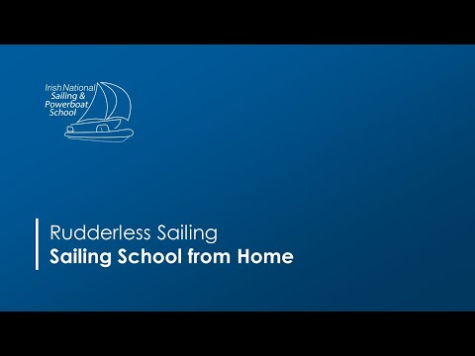

Rudderless Gybe

- Can sail backwards for short distances: You'll develop the technique to sail backwards for short distances. This is particularly useful in tight spots or when needing to create space. This often involves "backing" the mainsail (pushing the boom and sail out to the opposite side to catch the wind and generate reverse thrust) and using subtle rudder movements to control the stern's direction.


Emergency Response
- Can consistently recover a man overboard in moderate conditions and with little or no assistance from the instructor: This is a critical safety skill that demands consistency and independence. You'll be able to consistently recover a man overboard (MOB) in moderate conditions, performing the entire manoeuvre with little or no assistance from the instructor. This includes:
  - Rapid Response: Reacting immediately to the MOB event.
  - Manoeuvre Execution: Safely executing a specific MOB recovery manoeuvre (e.g., Quick Stop, Figure-of-Eight) to return to the person as swiftly and safely as possible.
  - Approach and Recovery: Precisely bringing the boat alongside the person, ensuring they are safely brought back on board without further risk.

Continuous Application of Principles
You'll continuously apply and master the 5 Essentials of sailing (Course Made Good, Sail Setting, Boat Balance, Boat Trim, and Daggerboard/Centreboard) to ensure your boat is always performing at its best. You'll specifically learn to:
- Optimise for Points of Sailing: Set up your boat to sail most efficiently when going upwind (pointing high and fast), downwind (getting the most push from the wind), or on a reach (maximizing speed across the wind).
- Maximize Leverage: Practice getting the maximum leverage when hiking to keep the boat flat and fast, transferring wind power into forward motion.
- Precise Sail Trim: Constantly adjust your sheets to trim your sails for optimal speed and pointing, using telltales as your continuous guide for perfect airflow.

Capsize Recovery:
At this level, you'll gain expertise in recovering from a fully inverted capsize, a more complex scenario requiring specific knowledge and techniques. This ensures you can handle challenging situations safely and efficiently.

Recovering from an Inverted Capsize
For dinghy and catamaran sailors, mastering the recovery from a fully inverted (upside-down) capsize is essential. You will learn the specific steps and techniques required for this more complex recovery:
- Will know how to get the centre/daggerboard down if it has retracted: You will acquire the knowledge and practical methods to get the centreboard or daggerboard down if it has retracted into the hull during the inversion. This is often crucial as the board provides the leverage needed to right the boat. You'll learn techniques like pulling on the board line or using specific methods to free it if it's jammed.
- Will know how to break a vacuum formed under the hull: You will understand and know how to execute the technique to break the "vacuum" that can form under the hull when a boat is fully inverted. This vacuum can make it incredibly difficult to right the boat. You'll learn methods such as pushing down on the bow or stern, or rocking the boat slightly, to allow air to enter and release the suction, making it possible to right the boat.
- Will know how to tell if mast is stuck in bottom and what to/not to do if it is: You will learn to recognize the signs that the mast of your inverted boat might be stuck in the seabed. This could include the boat feeling unusually rigid or a distinct "thud" during the inversion. You'll understand what to do (e.g., assessing the situation calmly, trying to gently release it if safe) and, crucially, what not to do (e.g., avoiding forceful righting attempts that could damage the mast or hull) if the mast is stuck.
- Can describe what to do if someone is caught under an inverted boat: You will be able to describe the critical steps to take if someone is caught under an inverted boat. The primary action is to quickly and safely bring the boat back to a capsized (on its side) position. This creates a larger air pocket and allows the person to easily exit from under the hull, making it much safer for them to surface and be recovered. You'll also learn the importance of immediate communication and reassurance with the person.
In addition to these specific points, you will also develop the general understanding of how to leverage your weight effectively on the centreboard or hull to apply sufficient force to flip the boat upright from its inverted state.

Boat Speed:
At this level, your focus shifts to extracting the highest possible speed and efficiency from your boat. This involves a constant interplay of theoretical knowledge, precise control, and physical technique, all geared towards optimising your boat's performance across various conditions and points of sailing.

Foundational Principles for Speed
- Are constantly aware of and apply “The 5 Essentials”: You will integrate "The 5 Essentials" – Course Made Good, Sail Setting, Boat Balance, Boat Trim, and Daggerboard/Centreboard – as a continuous, intuitive framework for achieving maximum boat speed. You'll move beyond merely identifying them to constantly apply them in real-time, making subtle and timely adjustments to maintain optimal performance. This includes striving for the best VMG (Velocity Made Good) on upwind and downwind legs(VMG means travelling at the highest speed possible towards your target which may not necessarily be your fastest speed).

Setting Up for Performance
- Can set the boat up: You will learn to expertly set the boat up for maximum performance tailored to the specific wind strength and water conditions of the day. This goes beyond basic rigging; it involves making the initial, subtle adjustments to the rig and controls (such as halyard tension, forestay tension/jib halyard tension, and outhaul/kicker settings) to create the most efficient and powerful sail plan before you even leave the shore. This pre-set optimises the boat for immediate speed.

Efficient Sailing on All Points
You will develop the refined skill to sail efficiently on every point of sailing, focusing on maximising your speed and CMG:
- Can sail efficiently up wind: You'll master the art of sailing efficiently upwind (close-hauled). This involves precise steering to maintain the closest possible course to the wind without sacrificing speed, continuous adjustments to mainsheet and jib sheets using telltales, and meticulous boat balance to minimise leeway and achieve the best possible CMG to windward.
- Can sail efficiently downwind: You'll learn to sail efficiently downwind by understanding how to extract maximum power and forward drive. This might involve sailing on a broad reach rather than directly running (to increase apparent wind and sail drive), precisely setting the kicker/vang and mainsheet to keep the mainsail full.
- Can sail efficiently on a reach: You'll excel at sailing efficiently on a reach (across the wind). This is often the fastest point of sailing. You'll learn to perfectly sheet your sails, use the daggerboard/centreboard to minimise drag while maintaining stability, and subtly adjust your course to maintain optimal apparent wind angle for maximum speed.

Physical and Sail Control for Speed
- Can demonstrate how to obtain maximum leverage when hiking: You will master the physical technique of hiking to obtain maximum leverage, effectively converting the wind's heeling force into forward drive. This involves positioning your body correctly, extending fully out over the side, and coordinating with the crew to keep the boat as flat as possible, especially in stronger winds, to maximise sail efficiency and minimise side-slippage.
- Can demonstrate use of optimum sheeting on all points of sailing: You'll develop an acute sensitivity to sail trim, allowing you to demonstrate the use of optimum sheeting on all points of sailing. This means:
  - Mainsheet: Constantly adjusting the mainsheet based on wind shifts, gusts, and lulls to maintain the perfect angle of attack and leech tension, guided by the mainsail telltales and boat feel.
  - Jib Sheets: Precisely trimming the jib sheets to ensure the jib works harmoniously with the mainsail indicated by perfectly streaming jib telltales. This continuous and precise sheeting ensures your sails are always generating maximum lift and drive for the conditions.

Weather: Advanced Forecasting and Meteorological Interpretation
At this level, you'll develop a sophisticated understanding of weather patterns, enabling you to critically interpret forecasts and make informed decisions that directly impact your sailing plans and safety.

Impact of Weather Elements on Planned Activities
You will gain a comprehensive understanding of how key weather elements can affect your sailing plans:
- Wind Speed: You'll accurately describe how wind speed, measured in knots, Kph, or expressed on the Beaufort scale, can affect your planned activities. This includes understanding the specific implications of:
  - Light winds: Requiring larger sails, potentially slower progress, and needing to manage momentum, possibly altering destinations due to limited speed.
  - Medium winds: Ideal for many activities but still requiring attention to trim and balance.
  - Moderate to Strong winds: Necessitating reefing or changing to smaller sails, potentially altering courses to avoid challenging sea states, increasing workload, and potentially leading to a decision not to sail at all if beyond your skill level or boat's capacity.
- Wind Direction: You'll describe how wind direction, indicated by compass headings, significantly affects planned activities. This includes:
  - Understanding the implications of onshore winds (e.g., easier return to shore but potentially larger waves near coast, more challenging landings).
  - Understanding offshore winds (e.g., pushing you away from land, potentially flatter water near shore, greater caution needed for safety).
  - How wind direction dictates your course relative to your destination, requiring tacking or gybing, and influencing choice of sailing area.
- Visibility: You'll describe how visibility, typically measured in nautical miles or meters, impacts your planned activities. Reduced visibility, especially due to fog or heavy precipitation, significantly increases collision risk. This may lead to:
  - Cancelling or delaying a trip.
  - Restricting sailing to familiar, open waters.
  - Necessitating increased vigilance, reduced speed, and the use of sound signals.
  - Altering a planned route to avoid busy shipping lanes or complex navigation areas.
- Precipitation: You'll describe how precipitation (rain, hail, snow) can affect planned activities. This includes:
  - Reduced visibility.
  - Slippery decks and gear, increasing risk of falls.
  - Discomfort for crew, leading to fatigue.
  - Potential for associated wind shifts or temperature drops.
- Temperature: You'll describe how temperature (actual air and water temperature) and the effects of wind chill can affect planned activities.
  - Low Temperatures & Wind Chill: Significantly increase the risk of hypothermia and frostbite, particularly if wet. This impacts clothing choices, duration of time on the water, and the need for warming strategies.
  - High Temperatures: Can lead to dehydration, heatstroke, and sunburn, necessitating sun protection and adequate hydration.

Sources of Weather Forecasts and Their Characteristics
You will be able to find forecasts on radio, VHF radio, television, internet, phone, fax & newspapers and identify the strengths & weaknesses of each type of forecast service:
- Radio (National Broadcasts):
  - Strengths: Widely accessible, often broad regional overview.
  - Weaknesses: Less specific to precise sailing areas, may not be regularly updated, no visual aids.
- VHF Radio (Marine Forecasts, e.g., continuous broadcasts or specific times):
  - Strengths: Specifically tailored for marine use, updated frequently, often includes current conditions and warnings relevant to local coastal areas.
  - Weaknesses: Requires a VHF radio, less visual information, can be missed if not tuned in at specific times.
- Television:
  - Strengths: Good for general overview, often includes synoptic charts and visual representation.
  - Weaknesses: Not usually marine-specific, less detailed for local areas, infrequent updates.
- Internet Websites (e.g., Met Éireann, Windy.com,):
  - Strengths: Highly detailed, often area-specific, frequently updated (some real-time), offers visual charts (synoptic, wind models), historical data.
  - Weaknesses: Requires internet access/data, can be overwhelming with too much data, potential for model differences.
- Phone Apps (e.g., dedicated marine weather apps):
  - Strengths: Convenient, portable, often customizable to specific locations, can offer push notifications for warnings.
  - Weaknesses: Relies on phone signal/data, may have limited detail compared to full websites, accuracy can vary between apps.
- Fax:
  - Strengths: Provides a hard copy, useful in areas with poor internet/radio.
  - Weaknesses: Outdated technology, less common, slow to receive updates, no real-time data.
- Newspapers:
  - Strengths: Readily available.
  - Weaknesses: Least timely, general forecasts, often outdated by time of reading.
- Local Harbour Masters / Sailing Centres:
  - Strengths: Highly localized, often based on direct observation and specific local knowledge, can provide practical advice.
  - Weaknesses: May not cover broader areas, relies on personal interpretation, availability can be limited.

Interpreting Marine Forecast Terminology and Synoptic Charts
You will be able to explain the significance of commonly used terms in marine forecasts and identify the significance to sailors of common weather patterns illustrated on synoptic charts:
- Isobars:
  - Significance: Lines connecting points of equal atmospheric pressure. You'll understand that closely spaced isobars indicate strong winds, while widely spaced isobars suggest lighter winds. They also show the general direction of wind (parallel to isobars, blowing from high to low pressure, with a deflection due to Coriolis effect in the Northern Hemisphere).
- Areas of High Pressure (Anticyclones):
  - Significance: Usually associated with stable, settled weather, light winds, clear skies, and fair conditions. Winds generally blow clockwise around high pressure in the Northern Hemisphere.
- Areas of Low Pressure (cyclones /Depressions):
  - Significance: Associated with unsettled, unstable weather, stronger winds, cloud, and precipitation. Winds generally blow anti-clockwise around low pressure in the Northern Hemisphere. You'll learn how these systems move and bring changing conditions.
- Cold Fronts:
  - Significance: Represented by a blue line with triangles. They indicate a boundary where colder air is displacing warmer air. Their passage often brings a sudden shift in wind direction (veering, typically to the right), a drop in temperature, squally winds, and showers or thunderstorms.
- Warm Fronts:
  - Significance: Represented by a red line with semicircles. They indicate a boundary where warmer air is replacing colder air. Their approach usually brings a gradual increase in cloudiness, steady rain or drizzle, and a backing of the wind (typically to the left) before the front passes, followed by warmer, often humid air.
- Common Weather Patterns on Synoptic Chart: You'll identify the significance of how these elements combine on a synoptic chart to form recognizable weather patterns (e.g., frontal systems approaching, ridges of high pressure, deep depressions) and predict their typical impact on wind, waves, and visibility for sailors.

https://www.met.ie/cms/assets/uploads/2024/07/OP-Fun-Facts-How-to-read-a-Weather-Chart-1.pdf

Applying Forecasts to Sailing Plans
- Can obtain a forecast for the day and then explain how the weather it predicts will affect the sailing area & activities planned for the day: You will confidently demonstrate your ability to obtain a weather forecast for the day from appropriate sources and then explain precisely how the weather it predicts will affect your specific sailing area and the activities planned for the day. This involves:
  - Critical Assessment: Evaluating the forecast for wind strength and direction changes, expected visibility, temperature shifts, and any precipitation.
  - Impact Analysis: Explaining how these elements will influence your decisions regarding:
    - Whether to go out: Assessing if conditions are within your skill level and boat's capabilities.
    - Sail choice and reefing: Determining if you need to use smaller sails or plan for reefing.
    - Course to take: Planning your route to leverage favourable winds/tides or avoid adverse conditions.
    - Safety precautions: Identifying necessary clothing, equipment, and contingency plans based on the predicted weather.
    - Adjusting the duration or scope of your trip.

Coastal Knowledge: Understanding Tides and Their Effects
At this level, you'll gain a deeper and more nuanced understanding of tidal phenomena, enabling you to predict their behaviour and plan your coastal sailing activities with greater precision and safety.

What Causes Tides
- Can describe what causes tides: You will gain a thorough understanding of the primary forces that cause tides. The dominant factor is the gravitational pull of the Moon, which exerts a strong attractive force on the Earth's oceans. The Sun also plays a significant role with its own gravitational pull, though its effect is about half that of the Moon due to its greater distance. As the Earth rotates, different areas experience the bulge of water caused by these gravitational pulls, resulting in the cyclical rise and fall of sea levels known as tides.

Neap and Spring Tides and Their Impact
- Can describe how neap and spring tides might affect sailors: You'll learn to differentiate between spring and neap tides and understand their distinct impacts on water levels and tidal streams, which are critical for effective sailing.
  - Spring Tides:
    - When they occur: These occur when the Sun, Moon, and Earth are approximately aligned in a straight line (during new moon and full moon phases).
    - Effect on Tides: Their combined gravitational pull creates a larger tidal range, meaning higher high waters and lower low waters.
    - Effect on Sailors: For sailors, spring tides mean the water levels will fluctuate more dramatically. This is crucial for:
      - Access: Knowing if you can safely access shallow areas, harbours, or slipways at high tide, and conversely, being aware of very low waters that could leave your boat grounded or unable to launch/recover.
      - Tidal Streams: During spring tides, the tidal streams (currents) will be at their strongest. This can significantly impact your boat's speed over the ground – either providing a strong assist or creating a powerful opposing force that can severely hinder progress or even push you backwards.
  - Neap Tides:
    - When they occur: These occur when the Sun and Moon are at right angles to each other relative to the Earth (during the first and third quarter moon phases).
    - Effect on Tides: Their gravitational pulls partially counteract each other, resulting in a smaller tidal range, meaning lower high waters and higher low waters.
    - Effect on Sailors: For sailors, neap tides mean the water levels will have less difference between high and low. This is useful for:
      - Access: Offering more consistent water depths, reducing the risk of grounding in marginal areas compared to spring tides.
      - Tidal Streams: The tidal streams (currents) will be at their weakest during neap tides. This makes sailing less affected by currents, potentially easier for navigation, and can be advantageous when needing to make progress against a stream that would be too strong during springs.
By understanding these tidal patterns, you'll be able to effectively plan your sailing times, assess the risk of grounding, and utilize or mitigate the effects of powerful tidal streams.

Sailing Knowledge: Hydrodynamics, Aerodynamics, and Force Dynamics
At this level, you'll delve deeper into the fundamental principles that govern how your boat moves and responds. You'll gain a sophisticated understanding of the forces generated by sails and foils, and how their interaction dictates your boat's performance and handling.

Understanding Forces: Lift Generation and Stalling
- Can describe how sails & foils generate lift and what stalling is: You'll learn the detailed mechanics of how both sails (acting as aerofoils in the air) and foils (like your daggerboard/centreboard and rudder, acting as hydrofoils in the water) generate the necessary lift to propel and steer your boat.
  - Lift Generation: This involves understanding that as fluid (air for sails, water for foils) flows over their curved surfaces, it travels faster on one side (the leeward side of a sail, or the low-pressure side of a foil). According to Bernoulli's principle, this faster flow creates lower pressure on that side, while the slower flow on the other side creates higher pressure. The difference in pressure results in a net force – lift – acting perpendicular to the direction of flow. For sails, this lift pulls the boat forward; for foils, it counteracts sideways motion (leeway) and provides steering force.
  - Stalling: You'll understand the critical concept of stalling. This occurs when the angle of attack (the angle at which the sail or foil meets the fluid) becomes too great, causing the fluid flow over the curved surface to break away and become turbulent instead of smooth and attached. When a sail stalls, it significantly loses its ability to generate lift and instead creates excessive drag. You'll learn to identify a stalled sail (e.g., telltales fluttering on the leeward side, lack of power, excessive heel with little forward speed) and how to rectify it (e.g., easing the sheet slightly or heading up to re-establish smooth airflow).

Force Interaction: Centre of Effort and Centre of Lateral Resistance
- Can explain how centre of effort (sails) & centre of lateral resistance (hull & foils) interact to drive boat forwards and to steer the boat: You'll learn about two crucial theoretical points and how their dynamic interplay is fundamental to driving your boat forward and enabling steering:
  - Centre of Effort (CE): This is the single theoretical point on the sail plan where all the wind's pushing force can be considered to act. Its position changes with sail trim and wind conditions.
  - Centre of Lateral Resistance (CLR): This is the single theoretical point on the underwater profile of the hull and foils (daggerboard/centreboard and rudder) where all the water's opposing sideways force acts. Its position changes with the boat's speed, heel, and daggerboard/rudder depth.
  - Interaction for Drive: When the CoE and CoLR are reasonably aligned (with CoE slightly ahead of CoLR for forward drive), the forces are balanced, and the boat moves efficiently forward with minimal unwanted turning.
  - Interaction for Steering:
    - If the CoE is too far aft of the CoLR, the wind force tries to turn the boat's bow away from the wind, resulting in lee helm (the boat wants to turn downwind, requiring you to push the tiller away from the boom to steer upwind).
    - If the CoE is too far forward of the CoLR, the wind force tries to turn the boat's bow into the wind, resulting in weather helm (the boat wants to turn upwind, requiring you to pull the tiller towards the boom to steer a straight course). You'll understand how to manage this balance through sail trim, daggerboard/centreboard position, and crew weight to achieve a slight, manageable amount of weather helm, which often provides the best feel and control.

What Next?
This section is super important because you now have many exciting choices for your next sailing adventure! You'll discuss with your instructor what you enjoy most in sailing (like racing, cruising, or trying different types of dinghies) and get personalized advice on the best next steps to continue your sailing journey and have even more fun! This might include specific advanced modules or joining a club's racing program.

